**Report**

# FET Box Final Report

ECEN 403

Team 16

Jacky Chen

Luke Bethancourt

Max Garza

Sydney Naddy

12/5/2024 FET CONTROL BOX

Jacky Chen

Luke Bethancourt

Max Garza

Sydney Naddy

# Concept of Operations

Concept of Operations

for

FET Control Box

Team <Jacky Chen, Luke Bethancourt, Max Garza, Sydney Naddy>

Approved by:

_____________________________

Project Leader Date

_____________________________

Prof. Lusher Date

_____________________________

T/A Date

## Table of Contents

**Table of Contents** 3

**List of Figures** 4

**1.** **Executive Summary** 5

**2.** **Introduction** 5

2.1. Background 6

2.2. Overview 6

2.3. Referenced Documents and Standards 6

**3.** **Operating Concept** 6

3.1. Scope 6

3.2. Operational Description and Constraints 6

3.3. System Description 7

3.4. Modes of Operations 7

3.5. Users 7 Support 8

**4.** **Scenario(s)** 8

4.1. ECEN 438 – Power Electronics 8

**5.** **Analysis** 8

5.1. Summary of Proposed Improvements 8

5.2. Disadvantages and Limitations 8

5.3. Alternatives 9

5.4. Impact 9

## 

## List of Figures

**Figure 1:** Product Functional Block Diagram **7**

## 

## Executive Summary

The primary purpose of the FET Control Box is for use in ECEN438, requiring ruggedness and reliability in an undergraduate lab setting. It must be easy to debug and repair, while also offering advanced performance suitable for research applications. The box contains two electrically independent pairs of Power MOSFETs and Power Diodes, along with control logic to generate three switching modes based on PWM control. These modes include identical switching, complementary with dead-time, and alternating switching. The FET Control Box supports a range of dc-dc, dc-ac, and ac-ac converters, and can be used individually or in a master-slave configuration for more complex systems.

## Introduction

This document describes the purpose and features of the FET Control Box, a device used to facilitate the construction and testing of power circuit topologies in a laboratory setting.

### Background

Power electronics and motor drives are common subjects covered in advanced undergraduate and graduate electrical engineering curricula. However, lab experiments in power electronics require advanced knowledge and understanding of the concepts that undergraduates will not always have starting in advanced undergraduate courses. Design of systems and circuits that power electronic courses go in depth into would be very complicated and frustrating with no prior experience.

For this reason, a FET Control Box was used at the University of Illinois to abstract away certain subject areas to make hands-on power electronics instruction practical for a university course. Students can study the prebuilt subsystems in the course to start off and be able to understand the functions that each module provides without needing to design an entire system from scratch. The FET Control Box is only intended for introducing new concepts to students in power electronics and allow students to eventually create equivalent circuits that can replace each module using their own designs.

The design resulting from the proposed project is intended to replace the existing FET Control Box used in a Texas A&M University course, ECEN 438, Power Electronics. As of currently, there is no replacement for broken FET Control Boxes, as they are more than 20 years old and originate from the University of Illinois.

The new design will be an updated version that replaces the currently used FET Control Box and provides an equivalent or more robust design suitable for use in lab settings. The intended lifetime of the device is to be at least 10 years, using components that can be easily replaced or last in the next decade.

### Overview

This document’s purpose is to describe in detail the operation, features, and limitations of the MOSFET Control Box intended to be used to complete the course ECEN 438, Power Electronics, offered by Texas A&M University.

### Referenced Documents and Standards

* Robert S. Balog, Fet Control Box Redesign 2002, Ref: DD00003, Issue: 001
* Robert S. Balog, Modern Laboratory-Based Education for Power Electronics and Electric Machines
* University of Illinois at Urbana-Champaign, Document Number: SK0003, Rev: 4

## Operating Concept

### Scope

The MOSFET control box is intended to be used to complete lab assignments in the course ECEN 438, Power Electronics, where students are required to build various switching power supplies and characterize their behavior. The FET Control Box is intended to abstract away the implementation of the switching component of power circuit topologies, so that instruction can solely be focused on power electronics design. To do this, the box contains two sets of power mosfets and diodes whose terminals–except for the mosfet gate–are exposed to the student, allowing them to add components to construct various power circuit topologies. The gate of the mosfet is driven either by an internal or external PWM signal with parameters set by the user.

### Operational Description and Constraints

All MOSFET and diode terminals–except for the MOSFET gate–are exposed to the user, allowing them to construct various power circuits using the power semiconductors in the box. The gate of the MOSFET is driven by a gate driver that is controlled by a microcontroller generating a PWM signal of frequency and duty cycle specified by the user; alternatively, an external signal or duty ratio can be used instead, via BNC connectors. The two MOSFETS can be operated in three modes: matching, alternating, and complementary, where the mosfets operate in complement with a short dead-time specified by the user. In addition to the operating mode and switching signal parameters being adjustable via physical knobs and buttons on the box, it can also be adjusted programmatically by connecting the box to a computer via USB.

Operating conditions and system constraints are specified below:

* Power mosfets and diodes must have absolute maximum ratings of 400V and 20A
* Minimal component safety features
  + - Overheat protection being the exception
* Operations manual is required to have following sections
  + - Operation
    - Troubleshooting
    - Parts list for repairability

### System Description

**Figure 1:** Product Functional Block Diagram

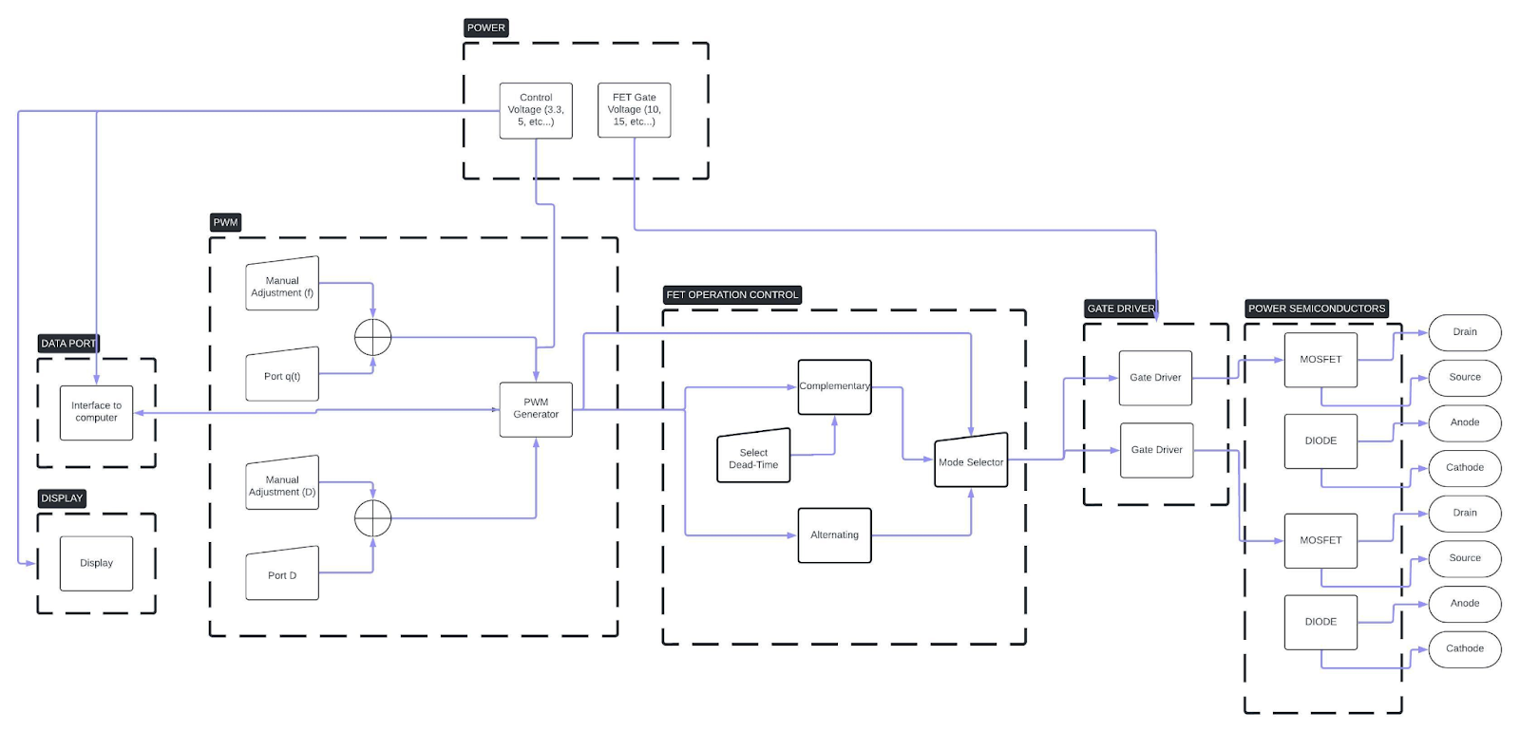

PWM:The PWM signal is generated by a microcontroller and can be controlled via knobs and buttons on the box, or programmatically via USB. Additionally, an external switching signal and duty ratio can be used via BNC connectors mounted on the box.

FET Operation Control: The mode of operation of the MOSFETS is specified by the user. The control logic is handled by a microcontroller.

Data Port: The mode of operation, frequency, and duty ratio can be controlled programmatically via command line on a computer. Data is sent to and from the box via USB.

### Modes of Operations

Matching: The two MOSFETS are switched using the same signal (i.e. they turn on and off at the same time).

Alternating: One MOSFET is switched on while the other is switched off. This mode would be used for implementing push-pull type circuits.

Complementary: MOSFETS are operated in complement with a short “dead-time”. This mode would be used for implementing half-bridge and synchronous-rectifier circuits among others.

### Users

Students in ECEN power classes will be using this device for labs to conduct experiments. There may also be applications for graduate students and researchers to use this device. Minimal training is needed due to its simple functions and user interface, with a manual included for details and proper use.

### Support

Support documentation will be available for the FET box and student lab manuals should provide basic details for students to use this device to complete their lab assignments. The students using the FET box will have the user manual for our group's design of the FET blue box and previous user manuals that Dr. Balog has written for his version of the FET box. In addition, Dr. Balog is a current professor at the university who can further support students in the operation of the FET box if necessary. The circuits within the FET box shall be designed to allow easy replacement of circuit elements.

## Scenario(s)

### ECEN 438 – Power Electronics

The FET Blue Box will be utilized in the laboratory component of ECEN 438, a course focused on the study of electric power conditioning and control, including solid-state power switches, AC power controllers, rectifiers, DC choppers, and DC-AC converters, with applications in power supplies, and airborne and spaceborne power systems. While the current control boxes used in the lab are adequate for instructional purposes, they were designed in the early 2000s, leading to a lack of available replacement parts and outdated components. The implementation of the FET Blue Box will modernize the lab equipment with updated components and enhanced features, ensuring easier maintenance and the availability of replacement parts.

## Analysis

### Summary of Proposed Improvements

The proposed improvements are the following:

* Microcontroller generated PWM signal
* PWM signal specifications can be programmatically controlled from a host computer over USB
* A display on the device will show PWM frequency and duty cycle
* Potentiometers will be replaced with a more accurate solution to physically adjust signal parameters.
* User Interface and Application integration

### Disadvantages and Limitations

Limitations of the proposed FET Control Box design include:

* Minimal component safety measures leave an opportunity for accidental damage to the device.
* Some characteristics of power circuit topologies will not be analogous to a practical implementation of them (i.e. there will be some discrepancies in power loss, noise, etc. between a topology implemented using the FET Control Box and a breadboard over a topology implemented on a PCB).
* The FET Control Box power semiconductors are rated for a maximum operating voltage and current of 400V and 20A.

### Alternatives

Alternative options aside from the FET Control Box include:

* Simulation software replaces the lab component of the course.
  + - Advantages:
      * Switching components can be sufficiently abstracted to solely focus on power electronics design.
    - Disadvantages:
      * Simulations of a circuit are not always a good analog to its physical counterpart
      * Students lose the opportunity to gain hands-on experience building power electronics circuits
* Students build the gate drive component of their power circuits themselves.
  + - Advantages:
      * Students gain hands on experience building power electronic circuits
    - Disadvantages:
      * Instruction time would be used to explain information outside the scope of the course.

### Impact

This project will facilitate students and professors at the university to test power circuit topologies. Our design will improve upon the current FET box that is being used in the ECEN 438 course, giving students an easier-to-use and reliable improvement to the FET box that is currently available.

FET Control Box

Jacky Chen

Luke Bethancourt

Max Garza

Sydney Naddy

# Interface Control Document

Interface Control Document

for

FET Control Box

Prepared by:

Team <Jacky Chen, Luke Bethancourt, Max Garza, Sydney Naddy>

Approved by:

_____________________________

Project Leader Date

_____________________________

John Lusher II, P.E. Date

_____________________________

T/A Date

**Table of Contents**

**Table of Contents** **12**

**1.** **Overview 13**

**2.** **References and Definitions 13**

2.1. References 13

2.2. Definitions 13

**3.** **Physical Interface 14**

3.1. Weight 14

3.2. Dimensions 14

3.2.1. Dimensions of Physical User Interfaces 14

**4.** **Thermal Interface** 14

**5.** **Electrical Interface** 14

5.1. Primary Input Power 14

5.2. Signal Interfaces 14

5.3. Video Interfaces 14

5.4. User Control Interface 15

**6.** **Communications / Device Interface Protocols** 15

6.1. Host Device 15

## Overview

This ICD—Interface Controls Document—will describe in detail: physical controls, thermal controls and electrical interfaces available to the user. Additionally, interfaces available to computers are also described in this document.

## References and Definitions

Provide any references (i.e., standards documents) and definitions. Examples are shown below.

### References

**IEEE 488.2**

**IEEE Standard Codes, Formats, Protocols, and Common Commands for Use With IEEE Std 488.1-1987, IEEE Standard Digital Interface for Programmable Instrumentation**

30 Nov 1992

**IEC 60320-1**

**IEC 60320 Appliance couplers for household and similar general purposes**

27 Jul 2021

### Definitions

**Table 1:** Definitions

| FET | MOSFET |
| --- | --- |
| USB | Universal Serial Interface |
| LED | Light Emitting Diode |
| kHz | Kilohertz (1000 Hz) |
| V | Volt |
| AC | Alternating Current |
| VAC | Volts Alternating Current |
| A | Ampere |
| mA | Milliampere |
| OLED | Organic Light Emitting Diode |
| PWM | Pulse Width Modulation |
| USBTMC | USB Test and Measurement Class |
| ICD | Interface Control Document |
| GPIB | General Purpose Interface Bus |
| ESD | Electro Static Discharge |
| kg | Kilogram |

## Physical Interface

The FET Control Box shall have the following physical specifications.

### Weight

The FET Control Box shall weigh no more than 15kg.

### Dimensions

The FET Control Box shall have an enclosure dimension of 12x10x8 inches.

#### Dimensions of Physical User Interfaces

* Power mosfets, power diodes, “q”, and “D” BNC jacks shall have a dimension of 6x3.5x2cm.
* Frequency and duty ratio rotary encoders shall have a dimension of 11.5x14.5 mm with a diameter of 6mm.

## Thermal Interface

The FET Control Box power mosfets and diodes will each be equipped with a heatsink to maintain operational temperature and prevent component damage due to overheating. Additionally, the FET Control Box enclosure will be vented to allow for airflow.

## Electrical Interface

### Primary Input Power

The FET Control Box will have one Universal IEC C13 receptacle for receiving 120VAC. A green LED light will turn on, indicating that there is power being supplied to the unit.

### Signal Interfaces

The FET Control Box will have two 6mm BNC jack connectors equipped with ESD protection for an external switching signal and duty ratio modulation.

### Video Interfaces

The FET Control Box will have an OLED screen to display the following information:

* Switching frequency
* Duty ratio
* Internal or external switching signal in use
* Mosfet operation mode

### User Control Interface

The FET Control Box will have the following physical controls available:

* Two rotary encoder knobs to adjust frequency and duty ratio
* Two push buttons to control switching mode and PWM operating mode
* Two sets of 6mm BNC jack connectors leading to:
  + Power mosfet drain
  + Power mosfet source
  + Power diode cathode
  + Power diode anode

## Communications / Device Interface Protocols

### Host Device

The FET Control Box will have a USB-A port mounted on the front panel that is intended to be used for communication with a computer.

FET Control Box

Jacky Chen

Luke Bethancourt

Max Garza

Sydney Naddy

# Functional System Requirements

Functional System Requirements

for

FET Control Box

Prepared by:

Team <Jacky Chen, Luke Bethancourt, Max Garza, Sydney Naddy>

Approved by:

_____________________________

Project Leader Date

_____________________________

John Lusher, P.E. Date

_____________________________

T/A Date

**Table of Contents**

**Table of Contents** **18**

**List of Figures** **19**

**1.** **Introduction 20**

1.1. Purpose and Scope 20

1.2. Responsibility and Change Authority 20

**2.** **Applicable and Reference Documents** 21

2.1. Applicable Documents 21

2.2. Reference Documents 21

2.3. Order of Precedence 21

**3.** **Requirements** 22

3.1. System Definition 22

3.1.1. Power Supply 22

3.1.2. FET Operation Control 23

3.1.3. PWM Generation 23

3.1.4. Web Application 23

3.1.5. Display 23

3.2. Characteristics 23

3.2.1. Functional / Performance Requirements 23

3.2.2. Physical Characteristics 23

Electrical Characteristics 25

**4.** **Support Requirements 26**

4.1. Operations Manual 26

4.2. Construction Manual 26

4.3. Computer Interface Requirements 26

4.3.1. Windows 26

4.3.2. Linux 26

**Appendix A: Acronyms and Abbreviations** **27**

## List of Figures

**Figure 1.** FET Control Box Conceptual Rendering (Front)20

[**Figure 2.** FET Control Box Conceptual Rendering (Side)](https://docs.google.com/document/d/1CoWoQ7RdIgay3lRynQ_QJHJP8p8lQSH0/edit#heading=h.23ckvvd)20

**Figure 3.** Block Diagram of System 22

# 

## Introduction

### Purpose And Scope

This specification defines the technical requirements for the development items and support subsystems delivered to the client for the FET control box.  Figure 1 shows a representative integration of the project in the proposed CONOPS. The verification requirements for the project are contained in a separate Verification and Validation Plan.

**Figure 1:** FET Control Box Conceptual Rendering (Front)

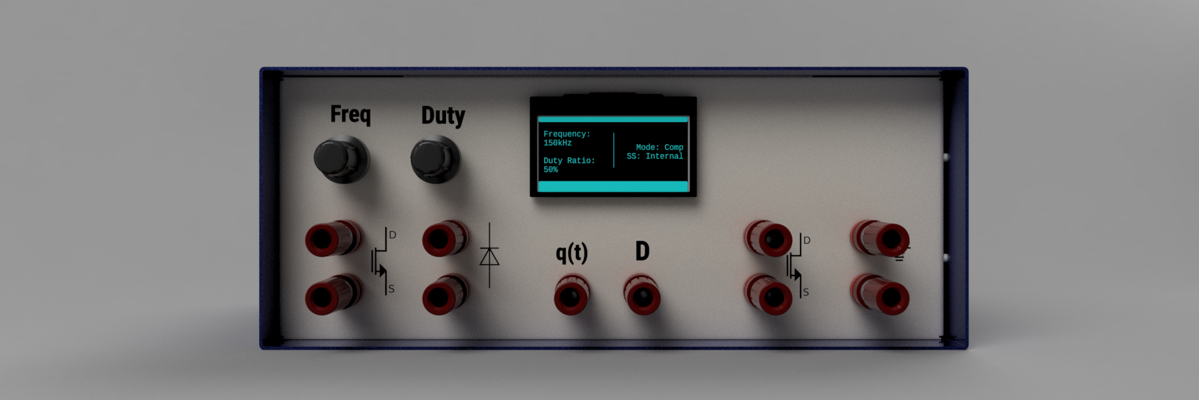

[**Figure 2:** FET Control Box Conceptual Rendering (Side)](https://docs.google.com/document/d/1CoWoQ7RdIgay3lRynQ_QJHJP8p8lQSH0/edit#heading=h.23ckvvd)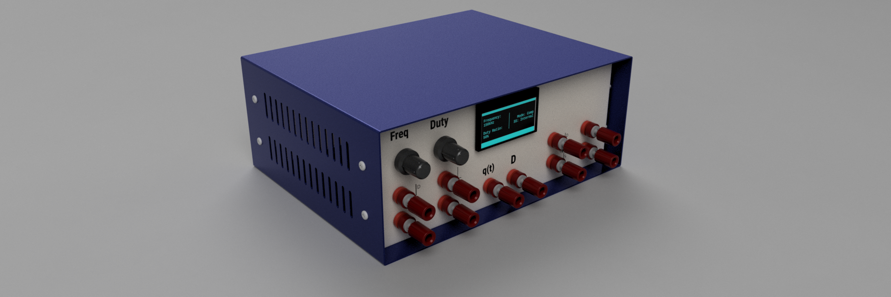

The following definitions differentiate between requirements and other statements.

Shall: This is the only verb used for the binding requirements.

Should/May: These verbs are used for stating non-mandatory goals.

Will: This verb is used for stating facts or declaration of purpose.

### Responsibility and Change Authority

The team leader Max Garza has the responsibility of making sure the project requirements are met. Furthermore, the group as a whole intends on keeping others in the group accountable for upholding the schedule and requirements of the project. The project sponsor Dr. Balog will also have authority to change the requirements of the project as he sees fit.

## Applicable And Reference Documents

### Applicable Documents

The following documents, of the exact issue and revision shown, form a part of this specification to the extent specified herein:

| **Document Number** | **Revision/Release Date** | **Document Title** |
| --- | --- | --- |
| IEEE 488.2 | 11/30/1992 | IEEE Standard Codes, Formats, Protocols, and Common Commands for Use With IEEE Std 488.1-1987, IEEE Standard Digital Interface for Programmable Instrumentation |
| IEC 60320 | 07/27/2021 | Appliance couplers for household and similar general purposes |

### Reference Documents

The following documents are reference documents utilized in the development of this specification. These documents do not form a part of this specification and are not controlled by their reference herein.

| **Document Number** | **Revision/Release Date** | **Document Title** |
| --- | --- | --- |
| DD00003 | 9/15/2004 | FET Control Box Redesign 2002 |
| 0885-8950 | 5/2/2005 | Modern Laboratory-Based Education for Power Electronics and Electric Machines |
|  | Version 1.4B –  8/2014 | ECEN 438 – Power Electronics Laboratory – Laboratory Manual |

### Order of Precedence

In the event of a conflict between the text of this specification and an applicable document cited herein, the text of this specification takes precedence without any exceptions.

All specifications, standards, exhibits, drawings or other documents that are invoked as “applicable” in this specification are incorporated as cited.  All documents that are referred to within an applicable report are considered to be for guidance and information only, except ICDs that have their relevant documents considered to be incorporated as cited.

## Requirements

This section defines the minimum requirements that the development item(s) must meet. The requirements and constraints that apply to performance, design, interoperability, reliability, etc., of the system, are covered.

### System Definition

This document describes the purpose and features of the FET Control Box, a device used to facilitate the construction and testing of power circuit topologies in a laboratory setting. The FET box controls the frequency and duty cycle of a PWM signal that is used to switch two power mosfets.

**Figure 3:** Block Diagram of System



There are four subsystems for the FET control box. The power semiconductors, gate drivers, and power supply is a subsystem; Jacky Chen will be responsible for implementing this subsystem. The microcontroller PWM generation and FET operation control logic is a subsystem; Luke Bethancourt will be responsible for implementing this subsystem. The PCB design, OLED display, and rotary encoder input is a subsystem; Max Garza will be responsible for implementing this subsystem. Finally, the last subsystem is a web application which uses SCPI commands to interface with the FET control box as a subsystem; Sydney Naddy will be responsible for this subsystem.

#### Power Supply

The power supply shall have the following requirements:

* Power from wall outlet shall be provided from an IEC power cord and receptacle
* Power supplied to the entire unit shall be isolated from mains power.
* Power supplied to the power mosfets and their gate drivers shall be isolated from control circuitry.
* The unit shall have a “Power On” LED, indicating that the unit is receiving power.
* Control circuitry shall be referenced to ground.
* The voltage range that it can take as an input

#### FET Operation Control

The two mosfets shall have the following three modes of operation:

* Matching – The two mosfets are switched on and off at the same time.
* Alternating – The two mosfets are switched on and off opposite to each other (i.e. while one is one the other is off and vice versa).
* Complimentary – The two mosfets are switched on and off opposite to each other, with a short dead-time between switching.

#### PWM Generation

The signal used to switch the power mosfets will be a PWM signal generated internally or an externally generated signal. The PWM generation system shall have the following requirements:

* Adjustable frequencies range from 1kHz to 300kHz.
* Adjustable duty ratio ranges from 5% to 95%.
* BNC connector, “q”, to allow for external switching signals.
* Switch to toggle between the internal or an external switching signal.
* Push button to toggle between three mosfet modes of operation *(Section 3.3).*

#### Web Application

The FET Box shall be able to be controlled programmatically from a web application installed on a computer. The host computer shall interface with the FET Box over a USB-A port mounted on the FET Box. The web application shall have the following features:

Sends commands over USB-A.

#### Display

* PWM signal parameters shall be displayed on the OLED display mounted on the unit.
* Current FET operation mode shall be displayed on the OLED display mounted on the unit.
* Internal or external signal status (i.e. which signal is being used) shall be displayed on the OLED display mounted on the unit.

### Characteristics

#### Functional / Performance Requirements

#### Power Mosfet Specifications

The two power mosfets shall have the following characteristics:

* Absolute maximum drain-source voltage of at least 800V
* Continuous drain current of at least 20A @ 25°C
* Acceptable packages:
  + TO-247
  + TO-220

#### Power Diode Specifications

The two power diodes shall have the following characteristics:

* Absolute maximum DC reverse voltage of at least 800V
* Average rectified current of at least 20A
* Acceptable packages:
  + TO-220-3
  + TO-247-3

#### Power Semiconductor Mounting

The power semiconductors shall be mounted using screw terminal blocks that have the following specifications:

* Single level
* Three positions
* Pitch greater than 3.50mm
* Voltage rating of at least 800V
* Current rating of at least 20A

#### Physical Characteristics

#### Mass

The mass of the FET control box shall be less than or equal to 15 kg.

*Rationale: Students and lab workers should be able to carry and lift the box without high risk of dropping them or hurting themselves.*

#### Volume Envelope

The volume envelope of the FET control box should be able to fit on a shelf with other equipment in a lab table.

*Rationale: The intended use in a lab setting where it will be placed among other equipment, such as an oscilloscope and bench power supply.*

#### Inputs

1. The presence or absence of any combination of the input signals in accordance with ICD specifications applied in any sequence shall not damage the FET Control Box, reduce its life expectancy, or cause any malfunction, either when the unit is powered or when it is not.
2. No sequence of command shall damage the FET Control Box, reduce its life expectancy, or cause any malfunction.

*Rationale: By design, should limit the chance of damage or malfunction by user/technician error.*

##### Power Consumption

1. The maximum peak power of the system shall not exceed 16000 watts.

*Rationale:  To limit the risk of damaging components, the maximum peak power that the components can handle is 800V and 20A. The device is designed to be operated at maximum 400V and 10A.*

##### Input Voltage Level

The input voltage level for the FET Control Box shall be 265VAC to 85VAC.

*Rationale: The FET Control Box will be plugged into the wall with Universal IEC connectors.*

##### Isolation

The FET Control Box shall not interfere with the components being used in experiments (i.e. the power mosfets and diodes)

*Rationale: The power given to the mosfet gate driver circuit, in addition to the switching signal applied must be electrically isolated.*

##### External Commands

The FET Control Box shall document all external commands in the appropriate ICD.

*Rationale: The ICD will capture all interface details from the low level electrical to the high-level packet format.*

#### Outputs

##### Signal Input/Output

The FET Control Box has two BNC jacks available as input, “q” and “D”, where an external switching signal can be used to control the power mosfets, and an external signal can be used to modulate the switching signal.

*Rationale: These two inputs “q” and “D” are present in the original version of the design and are a key feature of the device.*

##### Data Transfer

The FET Control Box shall receive commands over USBTMC in compliance with IEEE 488.2.

##### Connectors

The FET Control Box shall use external connectors in accordance with IEC 60320-1.

*Rationale:  The IEC 60320-1 international standard defines power supply connectors and inlets used in electrical and electronic equipment, including laboratory equipment like the FET Control Box.*

## Support Requirements

### Operations Manual

The FET Control Box shall have an operations manual explaining how to use the following features of the device:

* PWM frequency adjustment
* Duty ratio adjustment
* Setting mosfet operation mode
* Using an external switching signal
* Modulation of duty ratio
* Automation using USB commands

### Construction Manual

The FET Control Box shall have a construction manual explaining step-by-step how to put together the device.

### Computer Interface Requirements

#### Windows

In order for a computer using Windows to control the FET Box over USB, the following requirements must be met:

* Installation of the NI-VISA driver
* 1 USB port available

#### Linux

In order for a computer using Linux to control the FET Box over USB, the following requirements must be met:

* 1 USB port available

# 

# 

# Appendix A: Acronyms and Abbreviations

| FET | Mosfet |
| --- | --- |
| USB | Universal Serial Interface |
| LED | Light Emitting Diode |
| kHz | Kilohertz (1000 Hz) |
| V | Volt |
| VAC | Volts Alternating Current |
| A | Amp |
| OLED | Organic Light Emitting Diode |
| PWM | Pulse Width Modulation |
| USBTMC | USB Test and Measurement Class |
| ICD | Interface Control Document |
| GPIB | General Purpose Interface Bus |
| ESD | Electro Static Discharge |
| kg | Kilogram |

FET Control Box

Jacky Chen

Luke Bethancourt

Max Garza

Sydney Naddy

**Execution Plan**

Execution Plan for FET Control Box

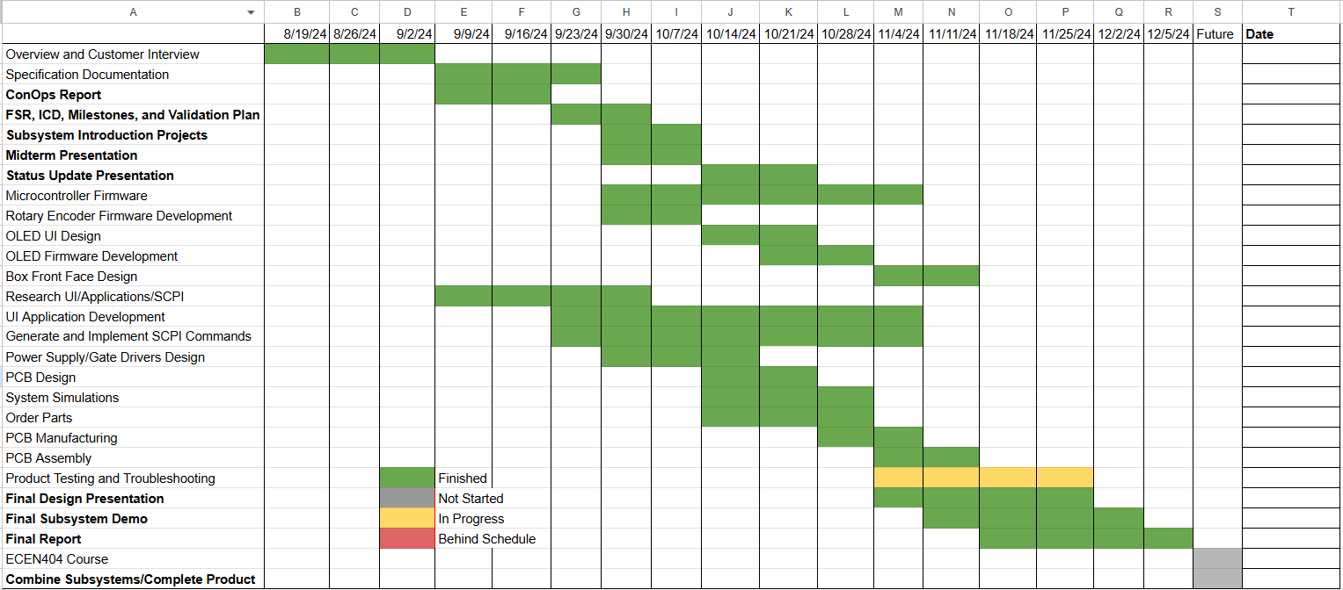

FET Control Box

Jacky Chen

Luke Bethancourt

Max Garza

Sydney Naddy

**Validation Plan**

Validation Plan for FET Control Box

| Paragraph # | Test Name | Success Criteria | Methodology | TESTED (incomplete) | Responsible Engineer(s) |
| --- | --- | --- | --- | --- | --- |
| 3.1.1 | Power Supply | The power supply draws 120VAC and outputs 12VDC and 10A through a full-wave rectifier. | Use a multimeter to validate DC output. | UNTESTED | Jacky |
| 3.1.2 | FET Operation Control | The two MOSFETS have 3 modes: Matching, alternating, and complimentary. | Test the system output signal for each mode using an oscilloscope or data analysis. | TESTED (success) | Luke |
| 3.1.3 | PWM Generation | Adjustable frequency range (1kHz to 300kHz) and duty ratio (5% to 95%). The signal can be toggled between an internal and external switching signal and allow toggling between the three MOSFET modes. | Test the system output signal for each mode using an oscilloscope or data analysis. | TESTED (success) | Luke |
| 3.1.4 | Web Application | Users shall be able to control the FET control box's PWM generation and control the power MOSFET modes via the web application. | Use Web application to adjust internal FET Box PWM, and use application to switch to each MOSFET mode of operation. | UNTESTED | Sydney |
| 3.1.5 | OLED Display | The screen shows the MOSFET mode, the set duty ratio, and the set frequency. | Visually inspect screen while adjusting frequency, duty cycle, toggling mosfet mode, and internal/external button. Measure switching PWM at the gates of the 2 mosfets to verify that the information on screen accurately reflects frequency, duty cycle, and operation mode. | UNTESTED | Max |
| 3.1.6 | Rotary Encoders | The two rotary encoders turn clockwise and counterclockwise and update the frequency and duty cycle respectively. Turning the knob quickly changes frequency or duty cycle in large increments and turning it slowly changes frequency or duty cycle in small increments | Physically turn knob. Measure the switching PWM waveform with an oscilloscope to ensure that the two rotary encoders change the frequency and duty correctly and proportional to the amount and speed turned. | TESTED (Success) | Max |
| 3.2.1.2 | Power Diodes | Average rectified current of 20A, maximum reverse VDC = 400V. | Test signal at 20A sent through power diodes. 400V reverse test signal sent at power diodes. | UNTESTED | Jacky |
| 3.2.1.3 | Power Semiconductor Mounting | Power semiconductors shall be mounted according to design requirements. | Movement of the box to determine if the parts are mounted properly. | UNTESTED | Jacky |
| 3.2.2.1 | Mass | The FET box is less than or equal to 15 kg. | Measure the box using a weight measuring scale. | UNTESTED | Max |
| 3.2.2.3 | Volume Envelope | FET box volume should be a reasonable fit on a lab table/shelf with other lab equipment. | Confirm that the box fits on the lab table/shelf alongside other standard lab equipment without issue. | UNTESTED | Max |
| 3.2.2.4.1 | Inputs | No absence, combination, or series of inputs in accordance with ICD specifications damage the FET control box, cause malfunction, or harm its life expectancy. | (1) Adjust frequency, duty cycle, mosfet operating mode, and use internal and external PWM modes while measuring gate drive output, mosfet drain-source voltage, diode cathode-anode voltage. Measure power semiconductor temperature. | UNTESTED | Sydney |
| 3.2.2.4.2 | Power Consumption | Maximum power draw should be no more than 16000 watts. | Use a multimeter to measure power draw of FET control box | UNTESTED | Jacky |
| 3.2.2.4.3 | Input Voltage | Input voltage shall be 240-85 VAC using a IEC 320 C13 receptacle | Use a multimeter to measure input voltage to FET control box | UNTESTED | Jacky |
| 3.2.2.4.4 | Isolation | Input signals and MOSFETs are isolated to prevent EMI. | Confirm that the output signal does not have significant noise or differ from expected when measuring it through an oscilloscope. | UNTESTED | Jacky |
| 3.2.2.5.2 | Data Transfer | FET Control Box frequency, duty cycle, operation mode, and internal/external PWM mode is able to be adjusted over USB using serial communication | Send commands to adjust internal PWM frequency and duty cycle. Send commands to cycle through mosfet operating modes. Send commands to toggle between internal/external PWM mode | TESTED (success) | Luke |
| 3.1.4 & 3.2.2.6.2 | Serial Port Connection | Data from the web application should be transferred from a computer to the FET box microcontroller by USB-A. | Web application sends information to the microcontroller that will indicate that information has been received. | TESTED  (success) | Sydney |
| 3.2.2.6.1 | System I/O | FET control box BNC jacks are able to switch the modes of the power mosfets reliably. | BNC jacks are used to switch to and from each MOSFET operating mode. | UNTESTED | Max |
| N/A | Full System Demo | A user can use the FET box for AC-DC, DC-DC, and DC-AC power supply topologies with the use of the analog and digital interfaces provided | Use of the web application and analog controls to demonstrate the ability to alter the PWM frequency and duty cycle, switching MOSFET modes of operation, and show the usability of the power MOSFETs and diodes. | UNTESTED | Full Team |

**Performance on Execution Plan**

The execution plan was mostly completed, however the testing and troubleshooting of the PCB was not completed during the semester. Most tasks were finished on the correct timeline and some tasks changed in their scope during the semester, so the execution plan was changed accordingly. The incomplete tasks will be a high priority going forward, and there will be more attention and accountability from the team to meet the expected deadlines presented in the execution plan.

**Performance on Validation Plan**

Due to the incomplete task execution plan the validation of some aspects of the project were not able to occur. This means some but not all testing and validation was able to be completed. Once the subsystems are integrated the validation of the system should be easier to complete, since some validation testing needs the integration of multiple subsystems to be completed. Each member of the group was tasked with getting some form of validation of their subsystem by the end of the semester, and this information will be included in the subsystem reports.

# Subsystem Reports

Subsystems Report for

FET Control Box

Prepared By:

Team <Jacky Chen, Luke Bethancourt, Max Garza, Sydney Naddy>

Approved by:

12/5/24 Project Leader Date



John Lusher, P.E. Date



T/A Date

# Table of Contents

**Subsystem Reports 35**

**Table of Contents 37**

**List of Tables** **39**

**List of Figures 4****0**

**1. Introduction 4****1**

2. Microcontroller Subsystem Report 42

2.1. Subsystem Introduction 42

2.2. Subsystem Details 42

2.2.1. Software 42

2.2.2. Hardware 43

2.3. Subsystem Validation 44

2.3.1. PWM Generation 44

2.3.1.1. Frequency Test 44

2.3.1.2. Duty Cycle Test 46

2.3.2. FET Operation Control: 48

2.4. Subsystem Conclusion 52

3. User Interface and Application Subsystem Report 54

3.1. Subsystem Introduction 54

3.2. App Components 54

3.2.1. Operation 54

3.2.2. Validation 55

3.3. MATLAB Code Architecture 56

3.3.1. Operation 56

3.3.2. Validation 56

3.4. Communication Commands 58

3.4.1. Operation 58

3.4.2. Validation 58

3.5. Subsystem Conclusion 60

**4. I/O Subsystem Report 6****1**

4.1. Subsystem Introduction 61

4.2. Subsystem Details 61

4.2.1. External PWM Capture 61

4.2.2. Encoder Control 62

4.2.3. Push Button Control 63

4.2.4. Display 63

4.2.5. Further Contributions 64

4.3. Subsystem Validation 65

4.3.1. External PWM Capture 65

4.3.2. Encoder Control. 65

4.3.3. Push Button Control 65

4.3.4. Display 65

**5. Power Supply Subsystem 67**

5.1. Subsystem Introduction 67

5.2. Subsystem Details 67

5.3. System Validation 68

5.4. Subsystem Conclusion 68

**6. Power Semiconductor Subsystem** **69**

6.1. Subsystem Introduction 69

6.2. Subsystem Details 69

6.2.1. MOSFETs and Diodes 70

6.2.2. Circuit Protections 70

6.3. System Validation 70

6.3.1. Test Circuit Set Up 70

6.3.2. Expected and Actual Results 71

6.4. Subsystem Conclusion 71

# List of Tables

Table 1: Microcontroller Subsystem Key Functions 42

Table 2: MATLAB App Components 54

Table 3: MATLAB App Functions 56

Table 4: Communication Protocol Functions 58

# List of Figures

Figure 1: Microcontroller Schematic 43

Figure 2: Microcontroller Layout 43

Figure 3: PWM Signal (1kHz) 44

Figure 4: PWM Signal (10kHz) 45

Figure 5: PWM Signal (100kHz) 45

Figure 6: PWM Signal (300kHz) 46

Figure 7: PWM Signal (5% Duty Cycle) 46

Figure 8: PWM Signal (25% Duty Cycle) 47

Figure 9: PWM Signal (75% Duty Cycle) 47

Figure 10: PWM Signal (95% Duty Cycle) 48

Figure 11: PWM Signal (Matching) 49

Figure 12: PWM Signal (Alternating) 49

Figure 13: PWM Signal (Complementary) 50

Figure 14: Frequency Command 50

Figure 15: External Command 51

Figure 16: Duty Cycle Command 51

Figure 17: Mode Command 52

Figure 18: MATLAB App Design 55

Figure 19: Sample MATLAB Code for App Components 57

Figure 20: Sample MATLAB Code For Communication Commands 59

Figure 21: I/O Subsystem Block Diagram 61

Figure 22: External PWM Capture Overview 62

Figure 23: Display Code Block Diagram 63

Figure 24: Altium view of MCU portion of PCB 64

Figure 25: Photo of PCB in the process of being assembled 65

Figure 26: Schematic diagram of the power supply outputs 67

Figure 27: Power supply section of the PCB (outlined) 68

Figure 28: Schematic diagram of the power semiconductors 69

Figure 29: PCB of the FETs (M1 & M2) and auxiliary diodes (upper isolated connectors) 69

Figure 30: Test circuit for a buck converter 70

# Introduction

The FET control box is a system that will allow multiple different power circuit topologies to be created for use in a lab setting. The system's behavior is controlled by the analog or digital inputs that are provided to the FET control box. The system is broken down into the microcontroller, UI and application, I/O, and Power supply subsystem. In the subsystem report each group member will report the validation and progress that they accomplished with their subsystem. The FSR and validation plan will provide the requirements and specifications for each subsystem to be seen as completed.

## Microcontroller Subsystem Report

### Subsystem Introduction

The purpose of the microcontroller subsystem was to generate two PWM signals that can be changed based on the frequency, duty cycle, operational mode, and external signal parameters. The input parameters can come from the microcontroller's communication with a PC using serial communication, or through the I/O subsystem which sets these parameters within the microcontroller. Another part of the subsystem was the creation of the PCB for the microcontroller, in which I co-authored the schematic and layout of the design.

### Subsystem Details

The microcontroller subsystem mainly focuses on three things, the generation of the PWM signal, reading and executing the commands, and the PCB. The PWM signal and reading and executing commands is the firmware for the microcontroller. Where the PCB design is the hardware for the subsystem.

#### 2.2.1. Software

The code for this project was written for a PIC32 microcontroller, so it was written in the MPLAB IDE. It consists of multiple functions that allow for the PIC32mz to generate the necessary signals and process the commands sent to it. Listed below are some of the key functions and their descriptions.

**Table 1:** Microcontroller Subsystem Key Functions

| Function | Description |
| --- | --- |
| Matching | Generates two identical PWM signals for the set frequency and duty cycle. |
| Alternating | Generates two identical PWM signals for the set frequency and duty cycle. |
| Complementary | Generates two identical PWM signals for the set frequency and duty cycle. |
| PWMGEN | Calls the matching, alternating, or complementary functions based upon the set operating mode that is set for the microcontroller. |
| UART_Task | Reads the data sent to the microcontroller, determines if the data is a command and sends it to be processed. |
| ProcessCommand | Gets the command received from UART_Task ready to be sent to SplitCommand. |
| SplitCommand | Takes the command given from ProccesCommand and separates it into two strings. The two strings are the number sent in the command and the word that specifies the command. Then these two strings are sent to be executed |
| commands | Receives the two strings from SplitCommand and determines what command is to be executed and implements the necessary changes |
| main | First initializes the system. Then it loops through UART_Task and checks if the PWM signals need to be updated, if so it updates the signals. |

The combination of these functions allows the microcontroller to produce the correct PWM signal for any mode, frequency, duty cycle within the specified requirements that is given as an input to the system.

#### 2.2.2. Hardware

The hardware for the microcontroller subsystem is mainly composed of the PIC32 microcontroller, a voltage regulator, USB connector, USB to serial IC, OLED display connector. The microprocessor takes the inputs from multiple sources, processes them and outputs the correct PWM signal to the gate drivers. The voltage regulator takes a 5 volt input from the power supply and drops it to 3.3 volts, so the microcontroller can operate at its target voltage. The USB connector and USB to serial IC takes the information sent by USB-A and converts it into serial. Finally, the OLED connector sends data between the microcontroller and the display.

**Figure 1:** Microcontroller Schematic

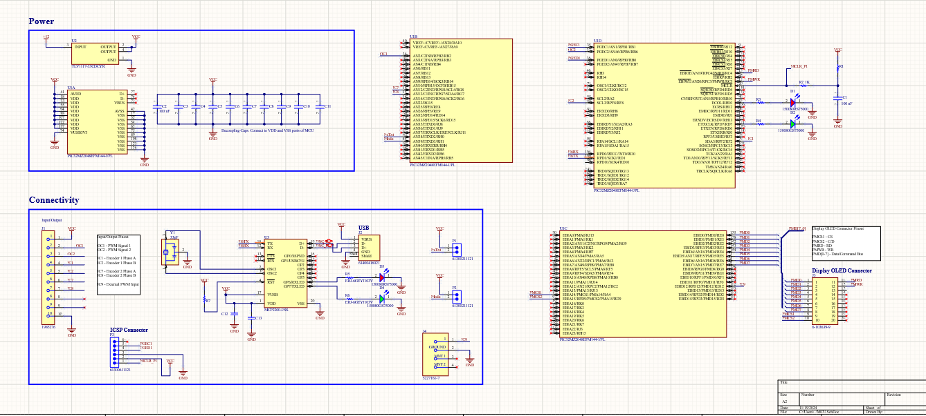

**Figure 2:** Microcontroller Layout

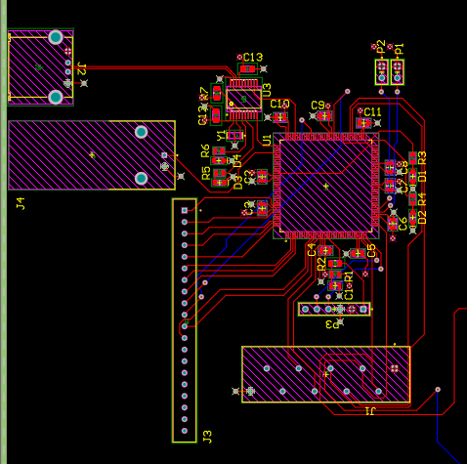

The schematics and layout have been completed for the PCB, and the microcontroller part of the PCB was solder and ready to be tested, Unfortunately, the microcontroller may have been damaged, or the soldering of the microcontroller was imperfect. This led to the inability to flash the PIC with our code. Therefore, the Validation of my subsystem was done on the PIC development kit.

### Subsystem Validation

There are three different validation tests that need to be completed for my subsystem to be complete in its entirety. The subsystem must execute PWM generation, Fet operation control, and Data transfer test successfully meeting the specifications laid out in the Validation Plan.

#### 2.3.1. PWM Generation

For my subsystem to successfully meet the requirements set for PWM generation for the microcontroller subsystem the signal generated must have an adjustable frequency range (1kHz to 300kHz) and duty ratio (5% to 95%). For testing of the PWM generation I have put together data that shows generated signals at the edge of and within the set frequency and duty cycle ranges.

These tests occurred on the PIC32 development board due to the inability to program the microcontroller on our PCB, most likely due to a soldering issue with the microcontroller. The results of the test will be accurate to what our system would produce, because we use the same microcontroller as the development board uses.

##### 2.3.1.1 Frequency Test

The PWM mode is set to matching and the duty cycle to 50%, changing only the frequency to multiple values at and between the range of 1kHz - 300 kHz. In the figures below are the generated signals for the stated frequencies that the microcontroller was set to produce.

**Figure 3:** PWM Signal (1kHz)

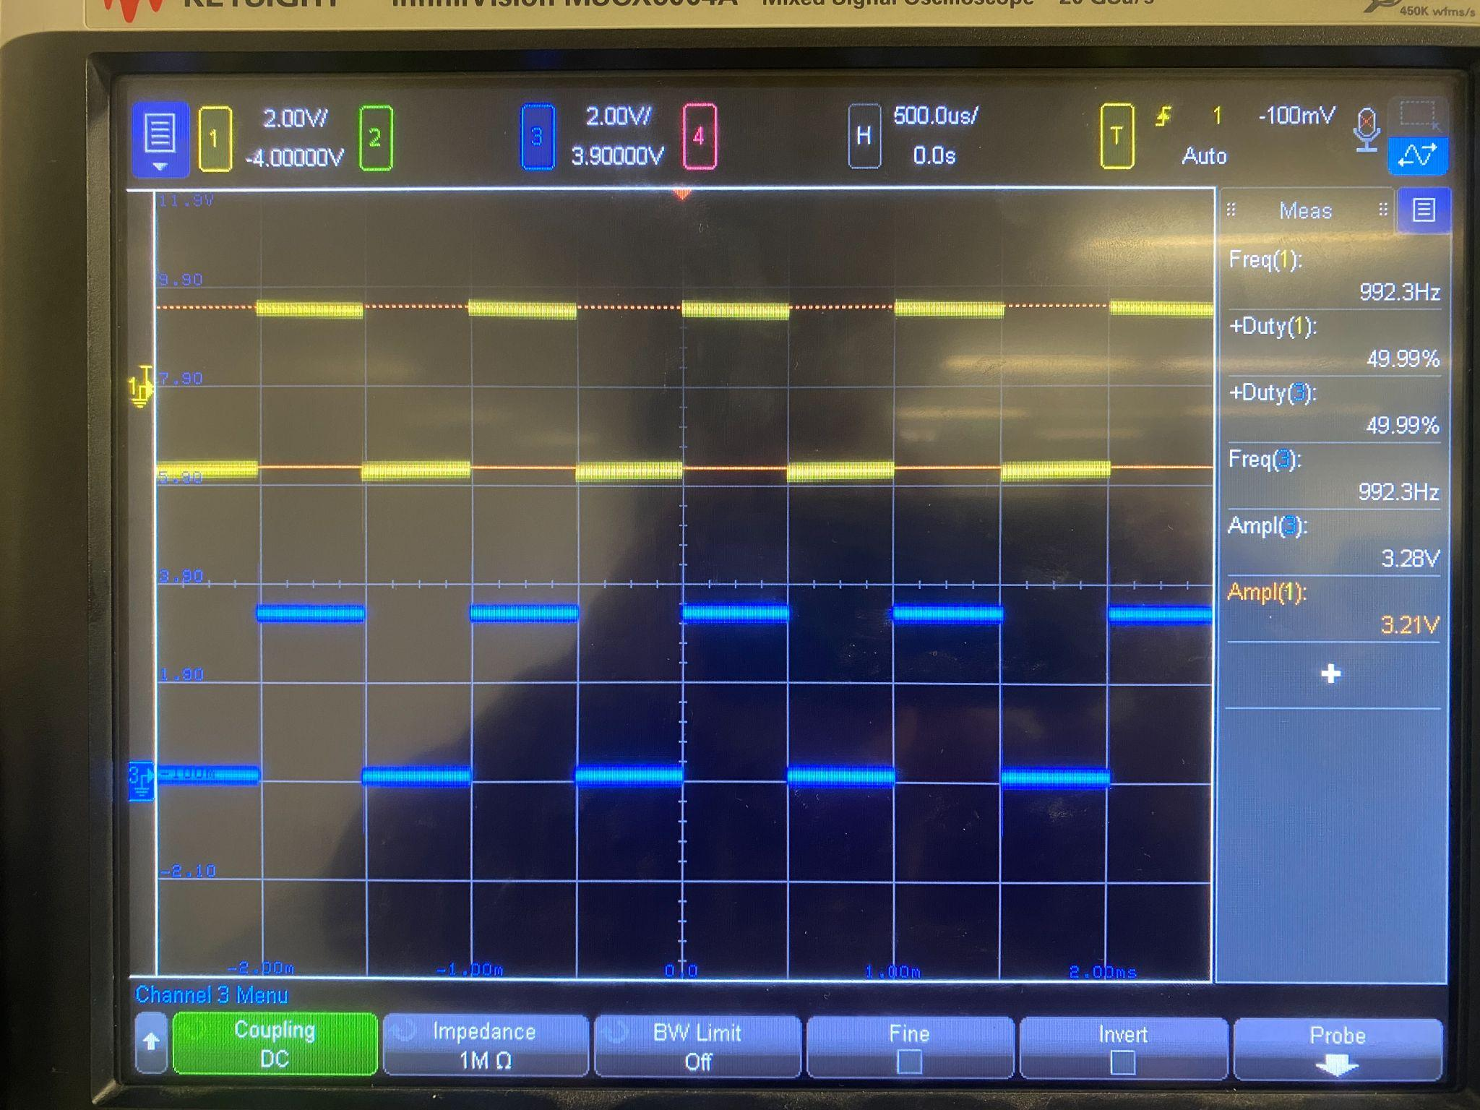

**Figure 4:** PWM Signal (10kHz)

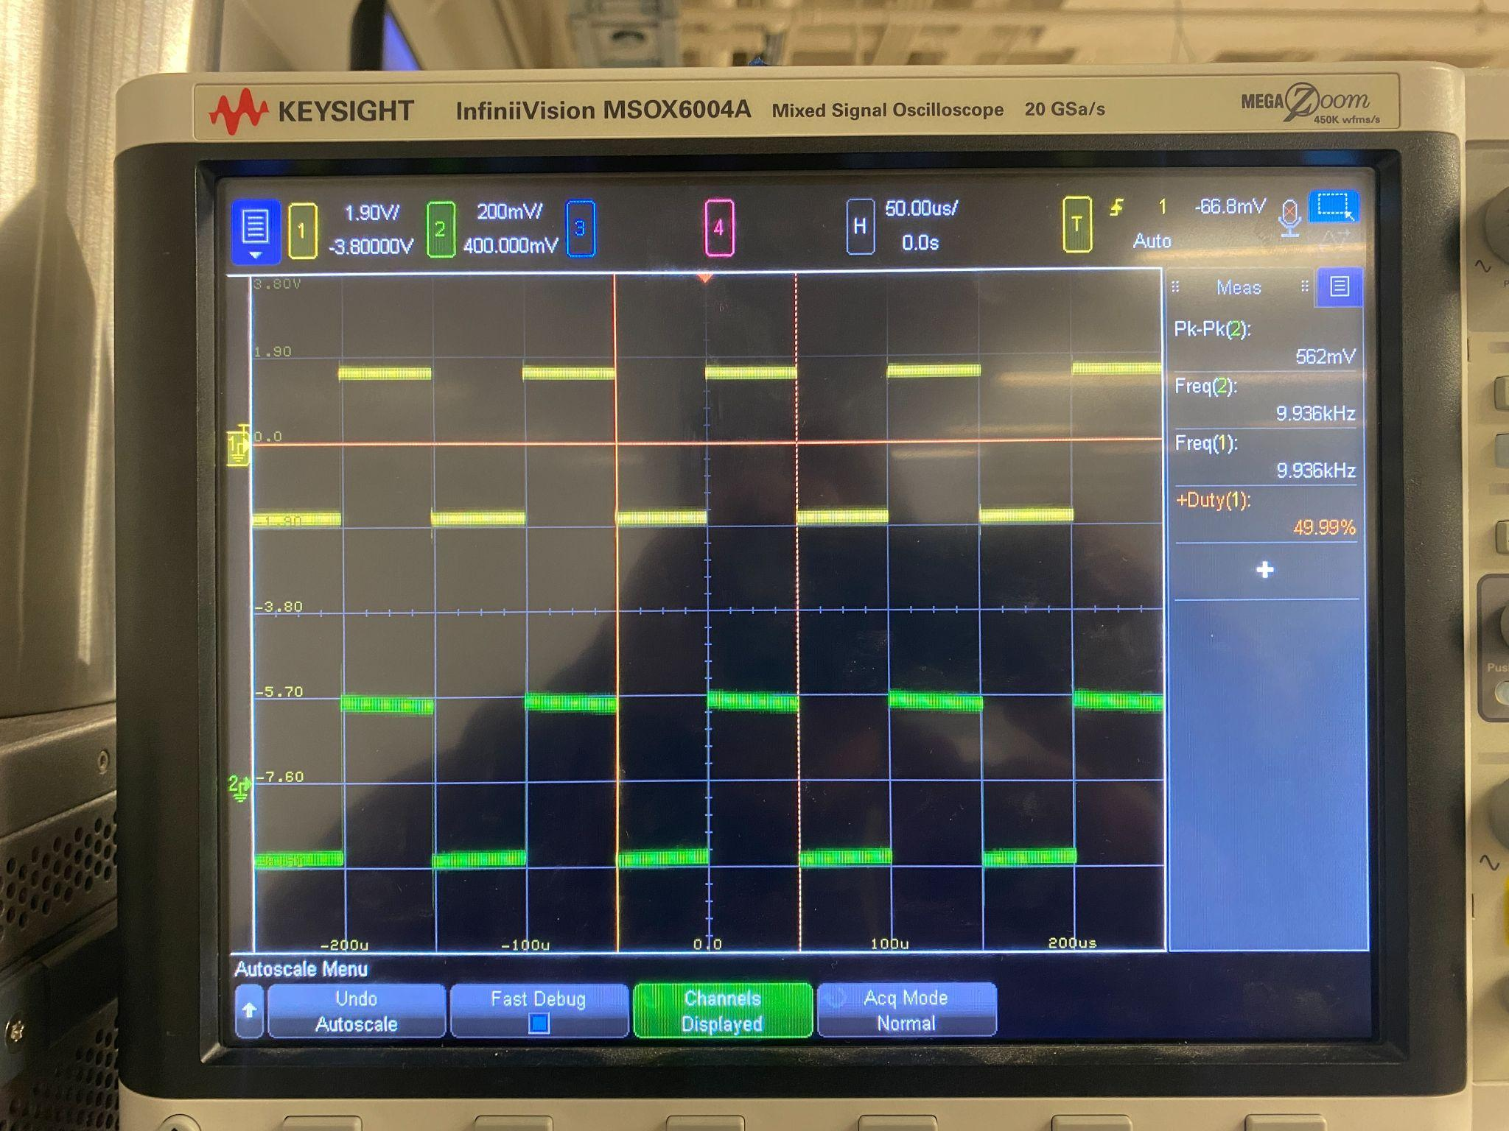

**Figure 5:** PWM Signal (100kHz)

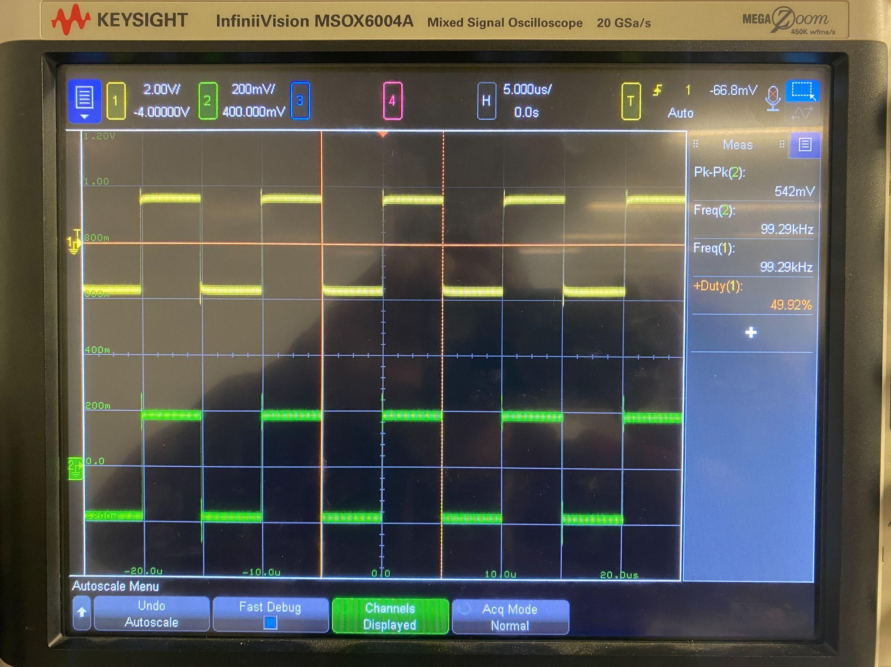

**Figure 6:** PWM Signal (300kHz)

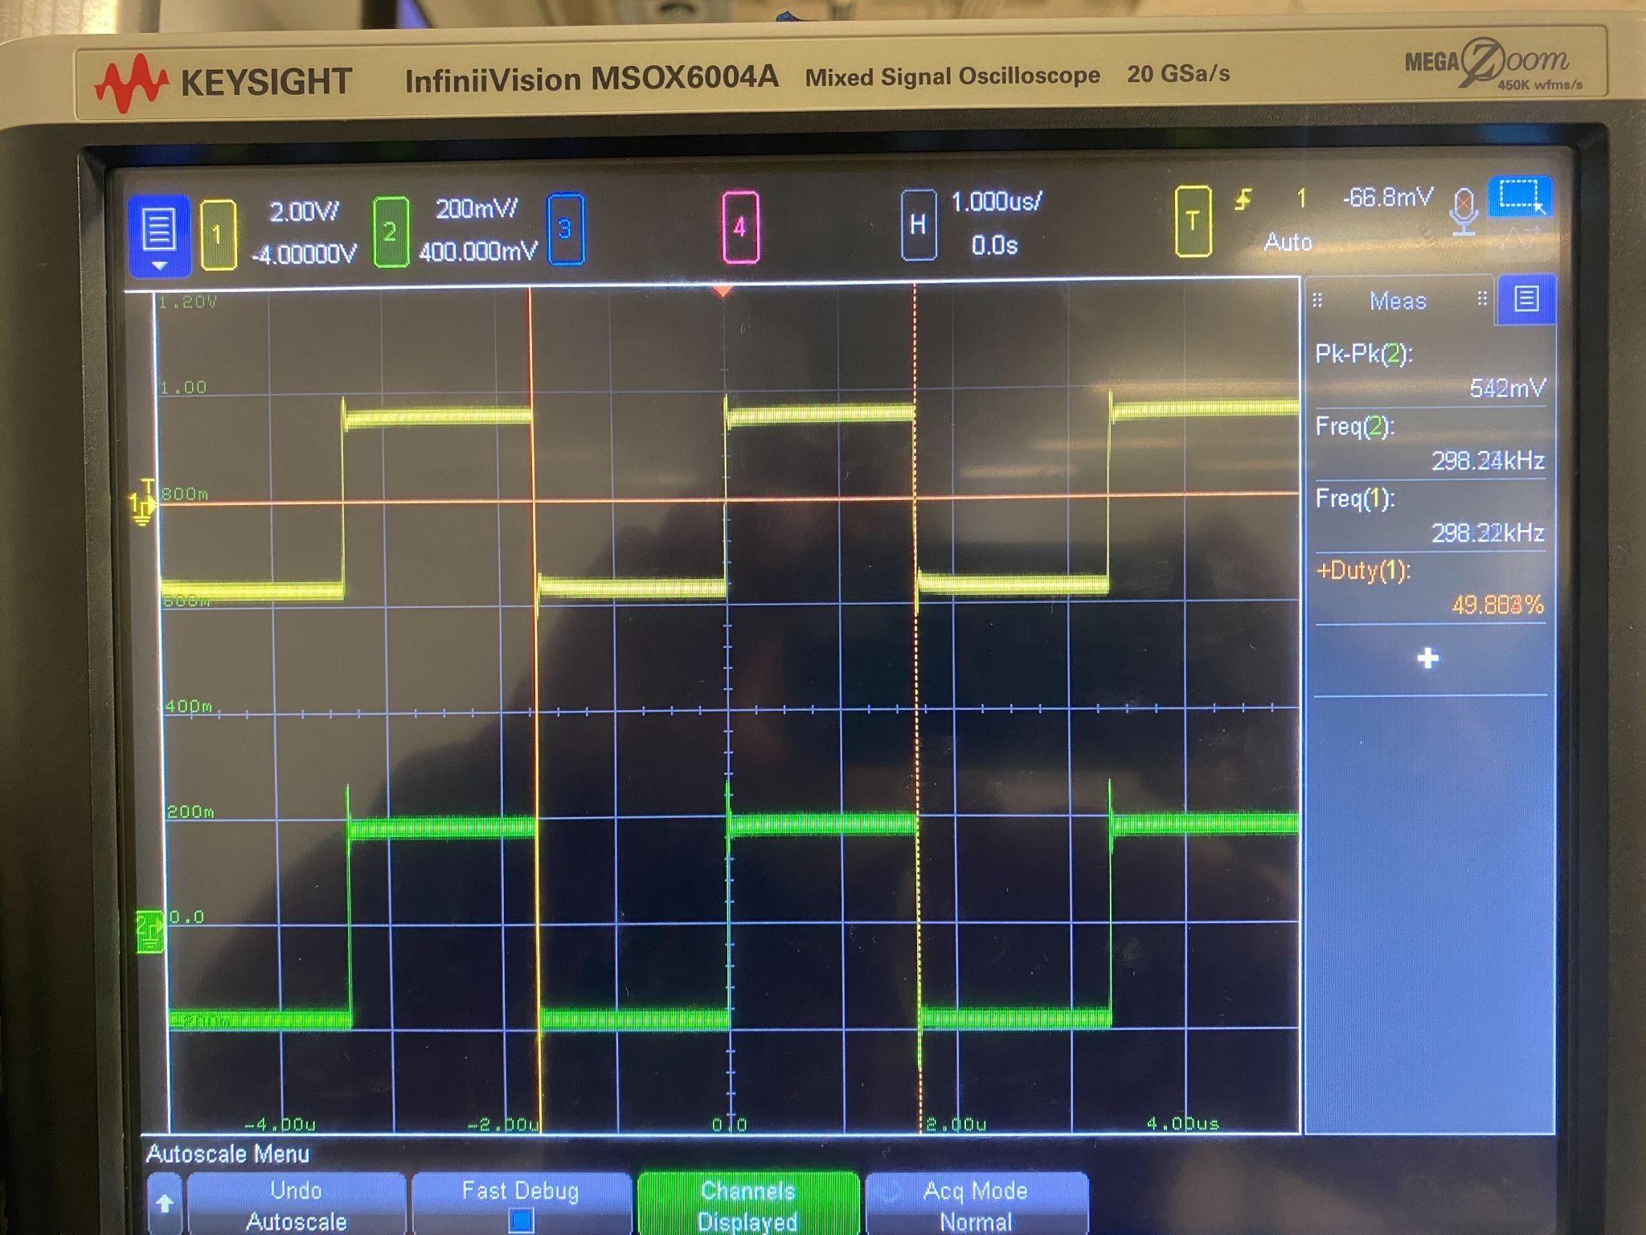

The PWM signals generated by the microcontroller are adjustable between the specified frequencies. The waveforms generated in figure 1-4 show that the signals can be generated at 1kHz, go as high as 300kHz, and be set frequencies in between this range.

##### 2.3.1.2. Duty Cycle Test

The PWM mode is set to matching and th e frequency of 10kHz for these tests, changing only the duty cycle to multiple values from 5% to 95% to see if the generated signals meet the specified requirements. Given below are the signals produced at the given duty cycles.

**Figure 7:** PWM Signal (5% Duty Cycle)

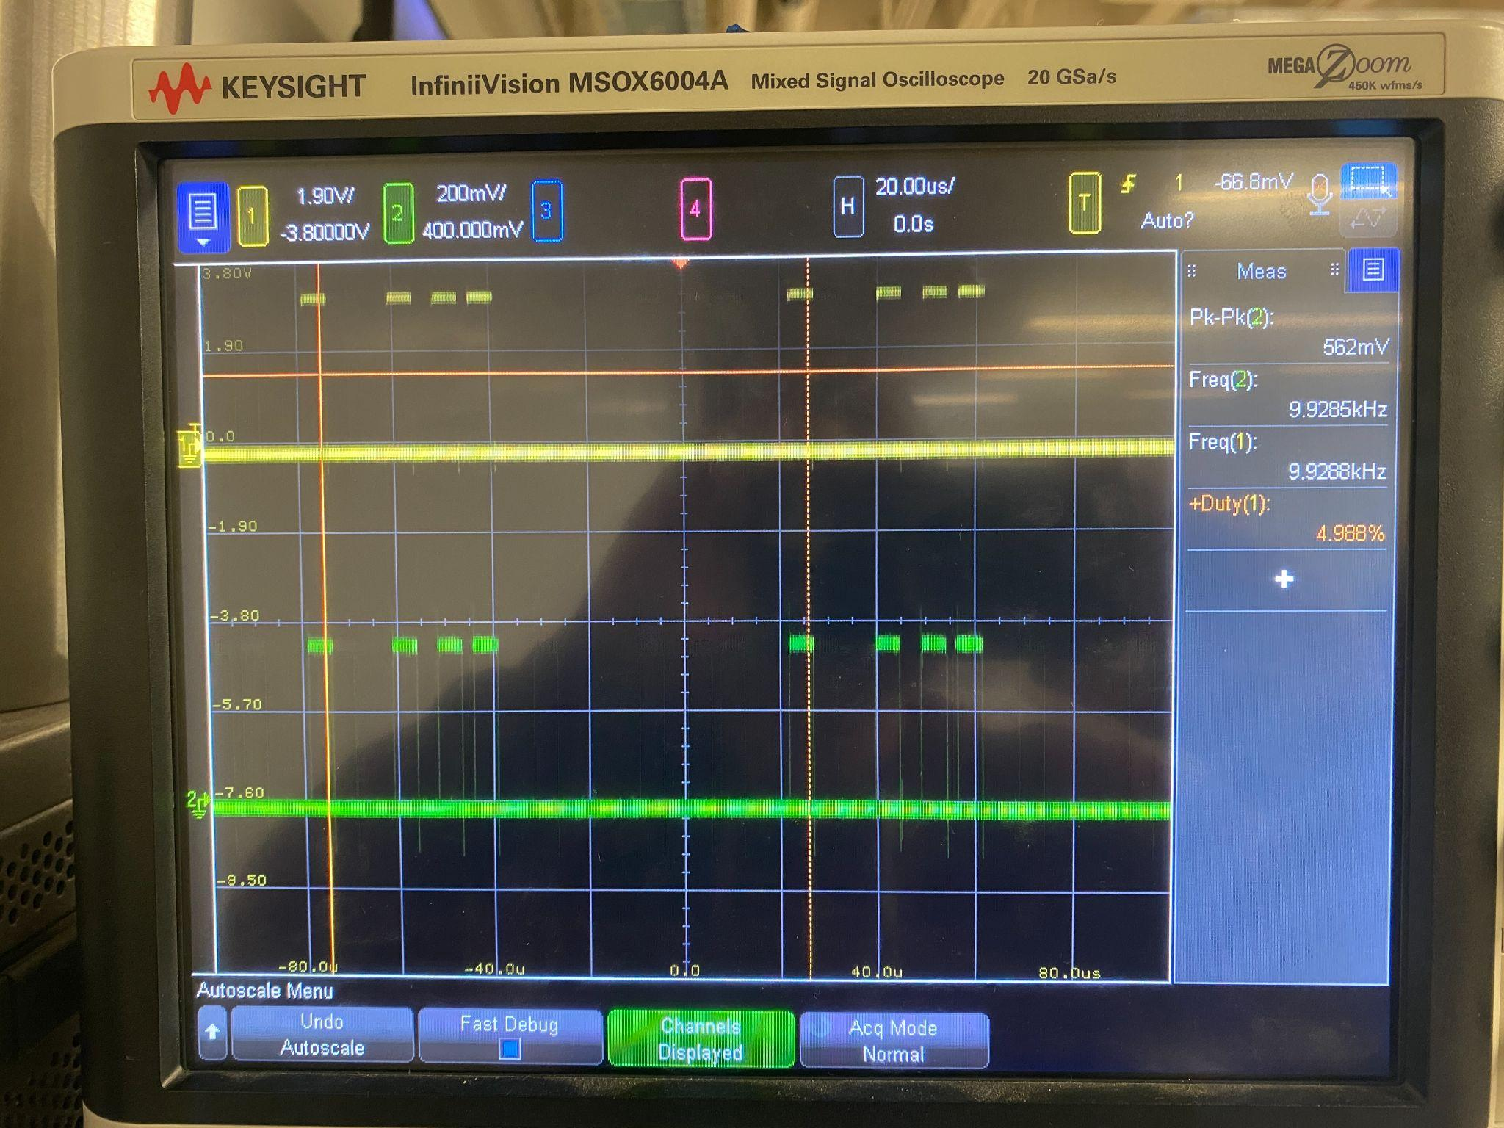

**Figure 8:** PWM Signal (25% Duty Cycle)

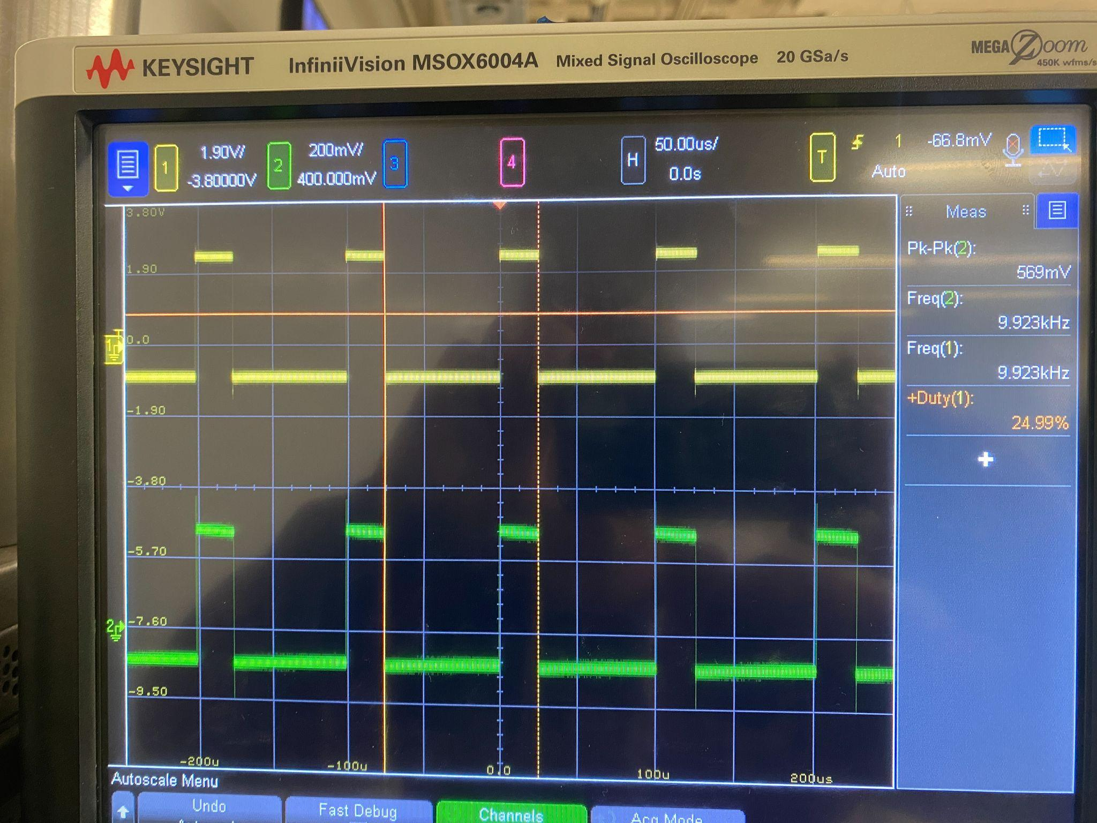

**Figure 9:** PWM Signal (75% Duty Cycle)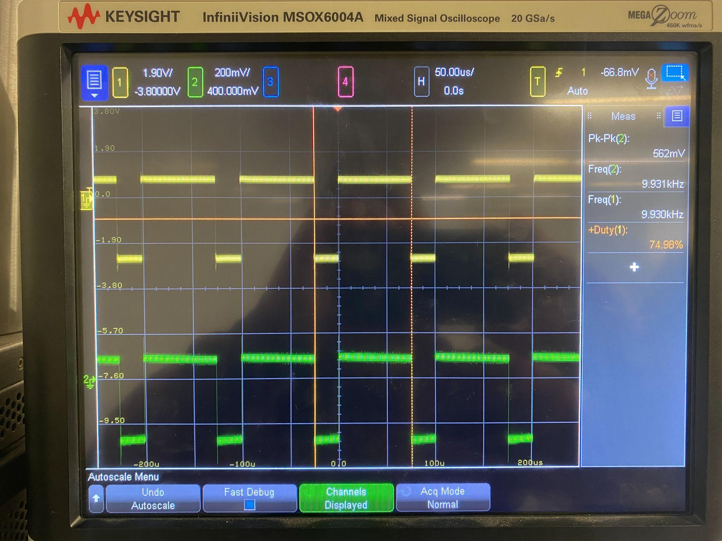

**Figure 10:** PWM Signal (95% Duty Cycle)

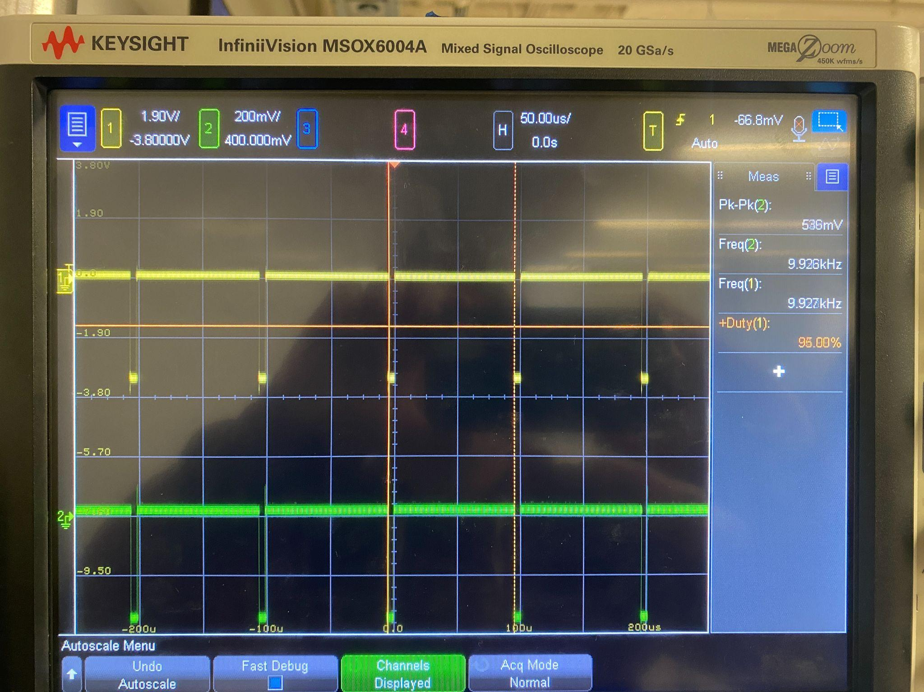

The Duty cycles of the waveforms presented in figures 5-6 produced meet the expectations of the validation test, and successfully show that the generated signals are adjustable between the duty cycles of 5% - 95%. The 5% duty cycle waveform does not look correct in the photo, this is because the waveform on the oscilloscope was constantly adjusting. I believe it is because at 10kHz the signal is high for a short amount of time, so the oscilloscope had trouble showing the signal because short strings of high voltage may seem like noise.

#### 2.3.2. FET Operation Control:

To successfully meet the requirements set for FET operation control the microcontroller should be able to generate two PWM signals that fit the behavior described in the FSR, section 3.1.2. There are three modes, and the microcontroller should be able to produce signals that are matching, alternating, and complementary to meet the requirements. The signals will be set at 10 kHz, 50% duty cycle, so that only the operating mode is changed during testing.

**Figure 11:** PWM Signal (Matching)



**Figure 12:** PWM Signal (Alternating)

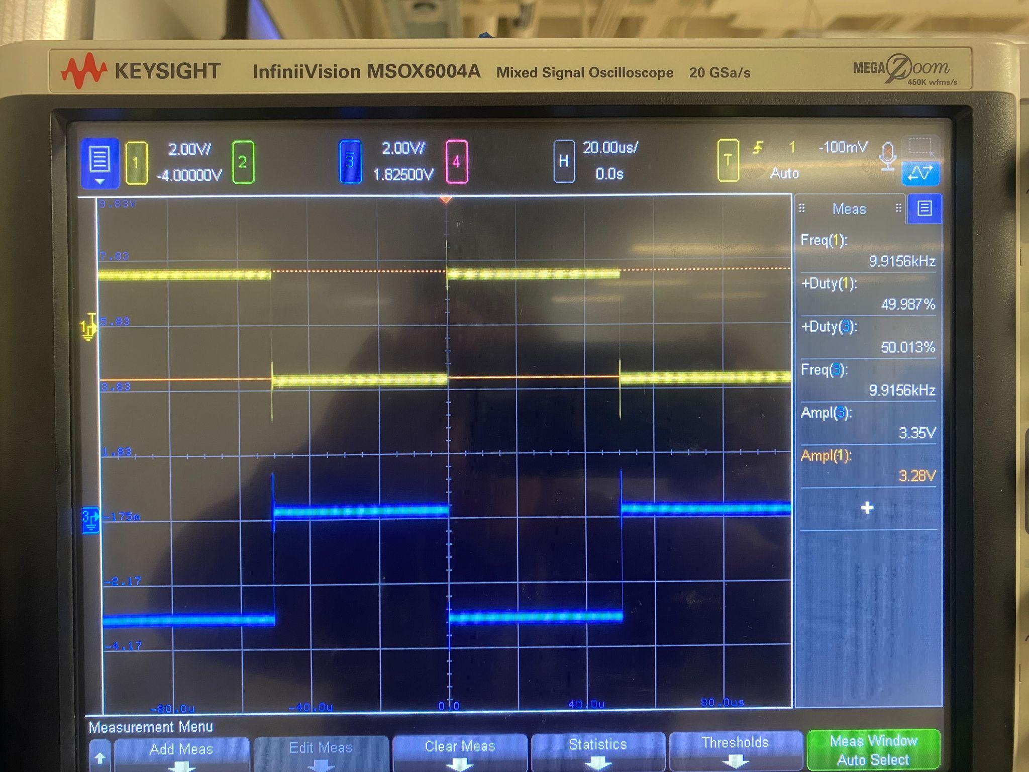

**Figure 13:** PWM Signal (Complementary)

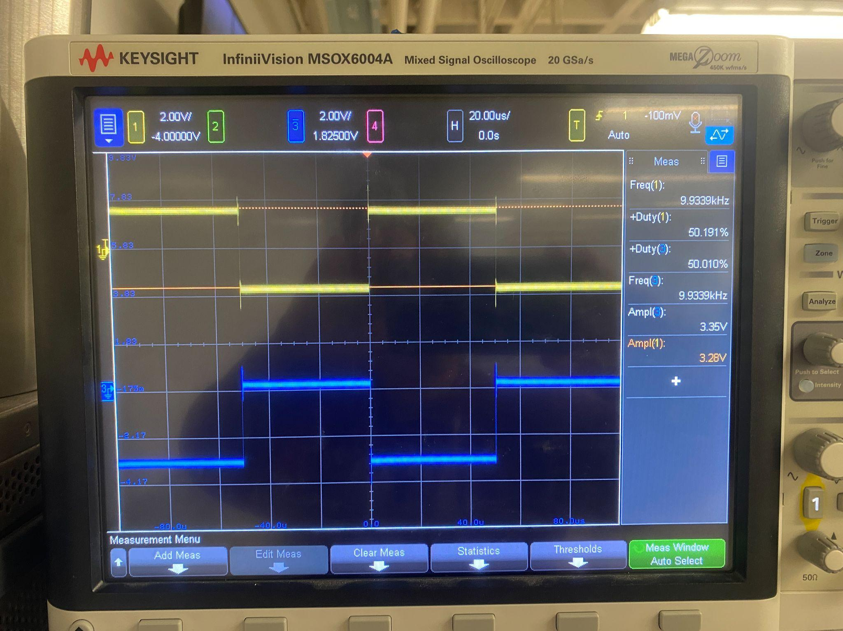

Each operational mode in the validation test has matched the expected behavior. The matching mode generates two signals that are the same, the alternating mode generates two signals that are opposing, and the complementary mode generates two signals that are opposite, but have a slight delay.

***2.3.3. Data Transfer***

To successfully meet the requirements of data transfer validation, the microcontroller must take commands from a PC or laptop, process them, and execute the commands. For this test I will be sending commands to the microcontroller via matlab, the microcontroller will then write back what command it processed to the computer.

**Figure 14:** Frequency Command

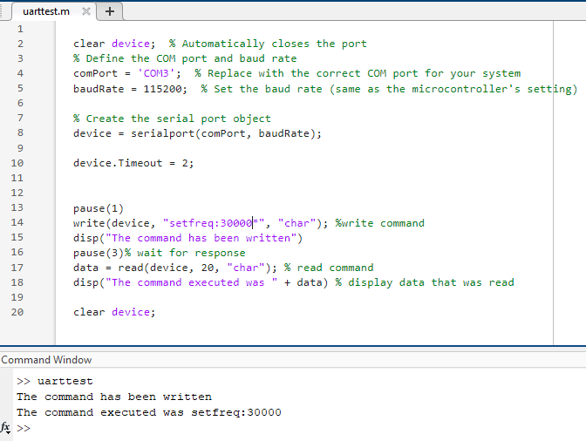

**Figure 15:** External Command

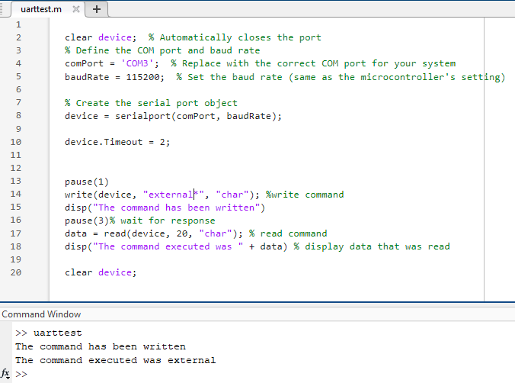

**Figure 16:** Duty Cycle Command

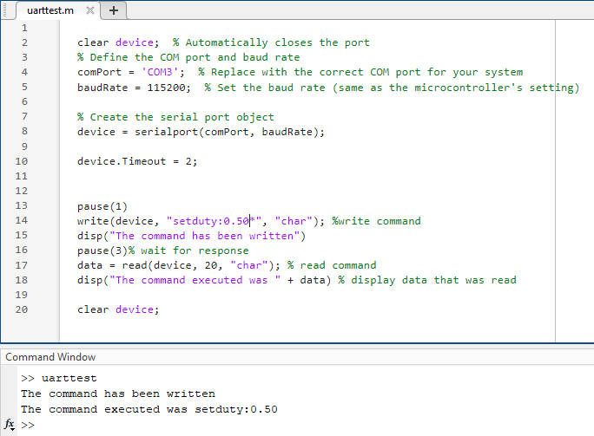

**Figure 17:** Mode Command

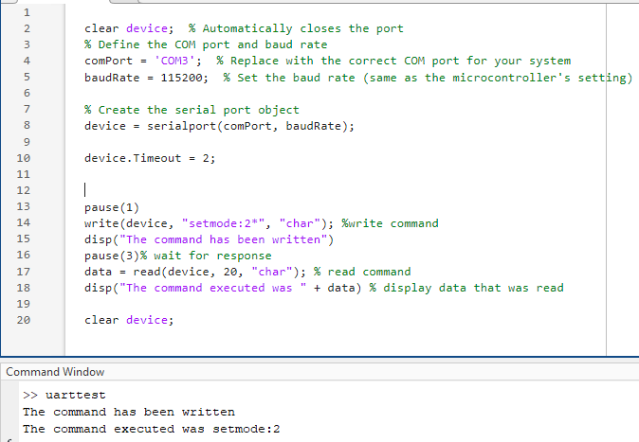

The microcontroller is able to read commands from matlab, process them, execute them, and write back the executed command to matlab as seen in the figures provided. The read command stores the string sent to the PC from the microcontroller into the variable data and displays the string in the console. The code is able to process each type of command that is necessary to change the PWM signal generated by the microcontroller, and switch the output signal to an external signal.

### Subsystem Conclusion

Based on the conclusion of my validation and testing the microcontroller subsystem delivers on generations PWM signals that meet the requirements expected from the FSR, and is able to communicate with a PC via serial communication. As mentioned the group's PCB was assembled, but it is currently not working properly. This is the part of the subsystem that has not been fully completed. The microcontroller subsystem is complete in terms of the software development and did not reach full completion on the hardware end. Once the hardware is completed without issue the microcontroller subsystem will be ready to integrate with the other subsystems to reach a final product.

## User Interface and Application Subsystem Report

### Subsystem Introduction

The user interface and application subsystem modernizes interaction with the FET box for ECEN 438 and research applications. Using MATLAB App Designer, the application replicates the box’s interface and functions, allowing students to adjust parameters and send commands directly. This design enhances usability and supports hands-on learning and research in power systems.

### App Components

#### Operation

The user interface is designed to replicate the functionality and appearance of the physical FET box, offering a clear and intuitive layout. Each component serves a specific purpose to facilitate user interaction. Key elements include buttons for connecting and disconnecting the device, knobs and edit fields for adjusting frequency and duty ratio, and visual indicators such as the power lamp. These components are housed in a UIFigure, which acts as the main application window, ensuring a seamless and organized interface for user interaction. A detailed table of components and their roles is provided below.

**Table 2:** MATLAB App Components

| UIFigure | App that holds all the components |
| --- | --- |
| FET1Image  FET1LabelImage | Image of BNC jacks for the anode, cathode, drain, and source for FET1 |
| FET2Image  FET2LabelImage | Image of BNC jacks for the anode, cathode, drain, and source for FET2 |
| qtDImage | Image of BNC jacks for q(t) and D for external signals |
| DeviceTextArea | Text area to display available serial ports and instrument ID |
| DeviceTextAreaLabel | Label of DeviceTextArea |
| ConnButton | Button to connect to device |
| DisconnButton | Button to disconnect from device |
| PwrButton | Button to simulate power off to device |
| PwrLamp | Lamp to show green/red for power on/off |
| SetFrequencyButton | Button to send frequency value to device |
| FreqEditField | Edit field to type a frequency value |
| FreqKnob | Knob to select a frequency value |
| SetDutyButton | Button to send duty ratio to device |
| DutyEditField | Edit field to type a duty ratio value |
| DutyKnob | Knob to select a duty ratio value |
| IntExtSwitch | Switch to select internal or external signal |
| ModeButtonGroup  matchButton  compButton  alternateButton | Button group to select which mode (matching, complementary, alternating) |
| NameEditField | Edit field to display user’s name |
| DatePicker | Date picker to display current date |

#### Validation

Each component was thoroughly tested for functionality and responsiveness through real-time interaction. Error messages were implemented to enhance usability and prevent invalid actions, such as attempting to change the frequency before connecting to the device. These messages guide users to follow the correct sequence of operations. Visual elements, such as the power lamp and status messages, were also validated to ensure they accurately reflect the system's state. Below is the user interface showcasing the physical design.

**Figure 18:** MATLAB App Design

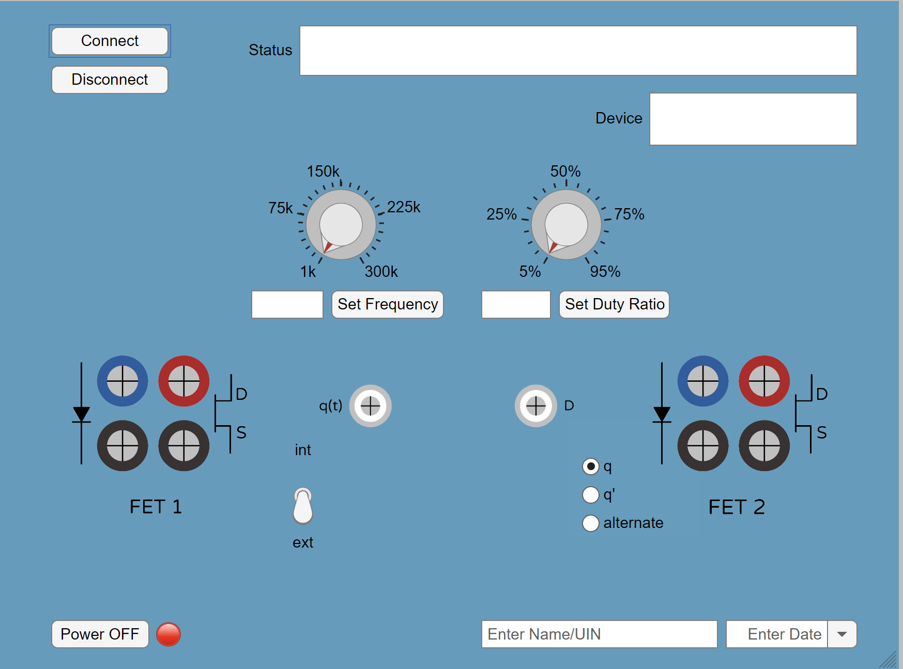

### MATLAB Code Architecture

#### Operation

The application’s functionality is closely tied to its components, with each function managing the behavior of specific interface elements. For example, the ConnButtonPushed function is associated with the connect button, enabling device connection and updating the status text area with available serial ports. The FreqKnobValueChanged and FreqEditFieldValueChanged functions ensure synchronization between the frequency knob and edit field, allowing seamless input updates whether the value is adjusted through the knob or typed into the field. This structured approach ensures that each component operates reliably and interacts cohesively with the rest of the interface. A detailed table of functions and their associated components is provided below.

**Table 3:** MATLAB App Functions

| ConnButtonPushed | Display available serial ports, assign port and baud rate, check if assigned port is available, create serial object |
| --- | --- |
| DisconnButtonPushed | Clear the serial object to close the connection |
| PwrButtonPushed | Update lamp color, button text, and status message to power on or off |
| FreqKnobValueChanged | Update frequency edit field to the user input’s knob value |
| FreqEditFieldValueChanged | Update frequency knob to the user input’s edit field value and check boundaries |
| SetFrequencyButtonPushed | Retrieve the frequency value from edit field, send frequency command to device |
| DutyKnobValueChanged | Update duty ratio edit field to the user input’s knob value |
| DutyEditFieldValueChanged | Update duty ratio knob to the user input’s edit field value and check boundaries |
| SetDutyButtonPushed | Retrieve the duty ratio value from edit field, send duty ratio command to device |
| ModeButtonGroupSelectionChanged | Retrieve which button was pushed, send mode selection command to device |

#### Validation

The integration of functions with interface components was thoroughly tested to ensure smooth operation. Boundary checking was implemented to guide user inputs; for example, if the user enters a frequency below the minimum allowed value, such as 500 Hz, the system automatically adjusts it to the minimum of 1 kHz. Additionally, students are required to enter their name and select the current date before proceeding with any operations, ensuring proper identification. These validations, along with error handling for invalid actions, ensure all components and functions work together seamlessly, providing a consistent and user-friendly experience. Below is a screenshot of a sample MATLAB code snippet illustrating the implementation of synchronous updates between the knob and edit field, as well as boundary checking.

**Figure 19:** Sample MATLAB Code for App Components

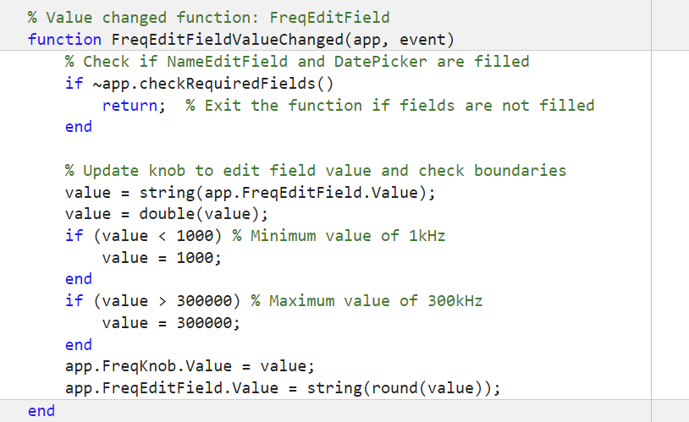

### Communication Commands

#### Operation

The application communicates with the FET box by sending commands that configure and control the device. These commands are triggered by user interactions, such as adjusting parameters or selecting modes, and are formatted to match the FET box's communication protocol. For instance, changing the frequency sends a command like “setfreq:5000*” to set the frequency to 5 kHz. Similarly, mode selection commands like “setmode:1*” allow the user to configure the FET settings. This structured communication ensures precise and reliable operation. A table of commands and their functions is provided below.

**Table 4:** Communication Protocol Functions

| “setfreq:5000*” | Set frequency value to 5kHz  (Range: 1kHz-300kHz) |
| --- | --- |
| “setduty:0.25*” | Set duty ratio to 25%  (Range: 5%-95%) |
| “setmode:1*” | Set FET2 configuration to match FET1 |
| “setmode:2*” | Set FET2 configuration to alternate FET1 |
| “setmode:3*” | Set FET2 configuration to complement FET1 |
| “external:1*” | Set system to receive an external signal |

#### Validation

The command system was validated to ensure proper formatting and successful transmission to the FET box. Each command was tested individually to confirm the device responded as expected, such as correctly setting the frequency, duty ratio, or mode. Additional validation was performed to ensure the application could handle invalid or out-of-bound commands gracefully, providing error messages to inform the user. Below is a screenshot of a sample MATLAB code snippet demonstrating how commands are formatted and sent to the device.

**Figure 20:** Sample MATLAB Code for Communication Commands

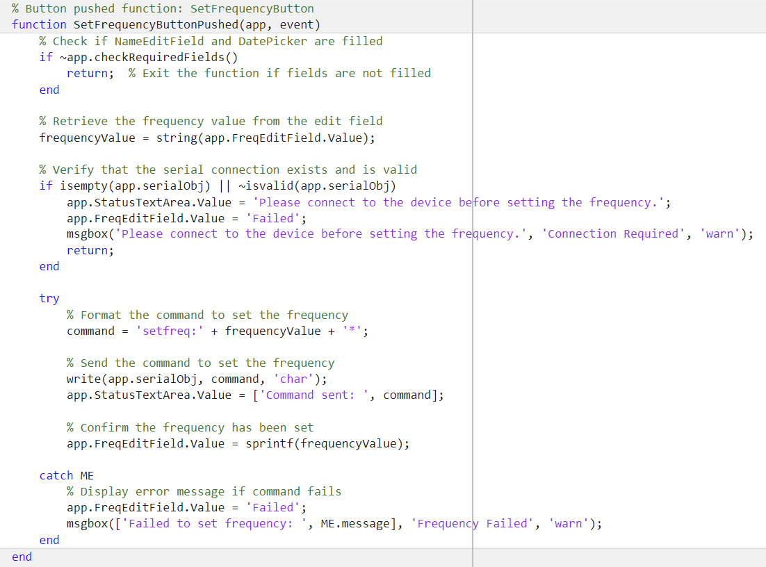

### Subsystem Conclusion

The user interface and application subsystem successfully modernizes the interaction with the FET box, enhancing both functionality and user experience. By replicating the physical interface digitally and integrating robust command and validation mechanisms, the subsystem provides a seamless platform for controlling and configuring the device. The use of MATLAB App Designer ensures flexibility and scalability, while error handling and boundary checking promote reliable operation. This subsystem not only meets the requirements of ECEN 438 and research applications but also sets a strong foundation for future enhancements and integration into modernized power systems laboratories.

# I/O Subsystem Report

### Subsystem Introduction

The I/O Subsystem handles—with the exception of the USB port—all interfaces that the user physically needs to operate the device (i.e. buttons, switches, displays). Through this subsystem, the user is able to emulate an external PWM signal; cycle through operation modes and toggle between internal or external PWM signals to drive the switching MOSFETS; adjust the internal PWM frequency and duty ratio; and be able to visually tell what mode, frequency, and duty ratio the device is operating at. The I/O Subsystem consists of 4 main components: External PWM Capture, Encoder Control, Push Button Control, and Display.

**Figure 21:** I/O Subsystem Block Diagram

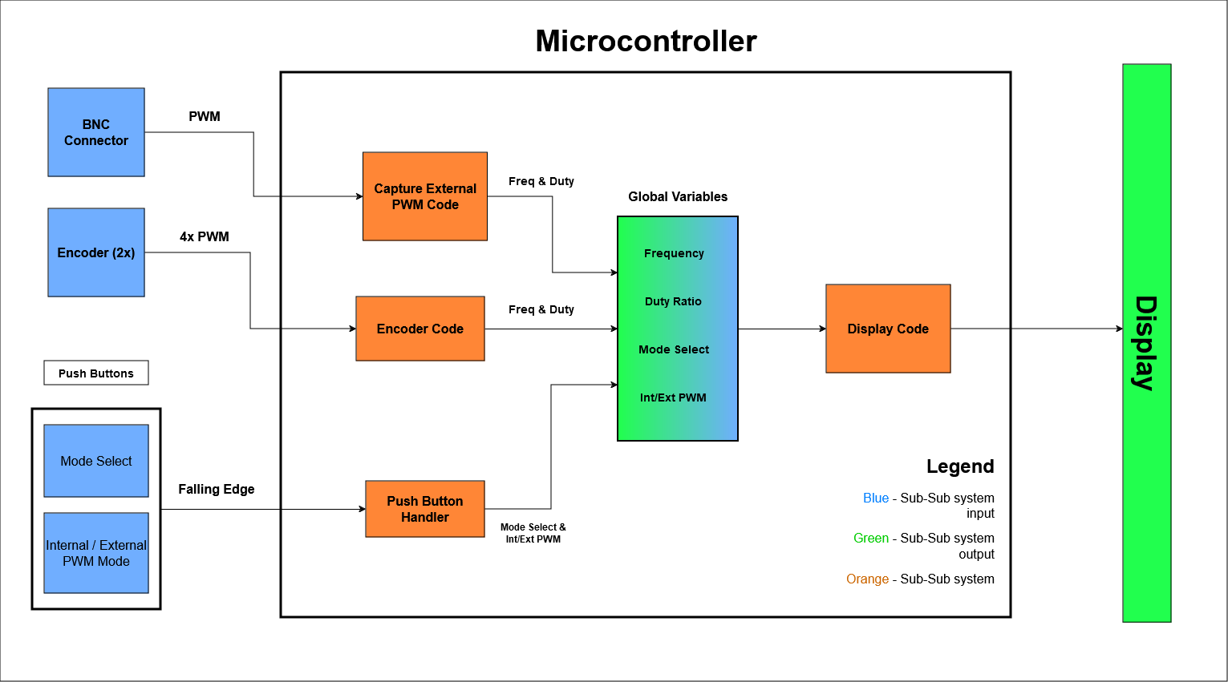

### Subsystem Details

#### External PWM Capture

The I/O Subsystem is tasked with capturing an external PWM signal and emulating it on the MOSFET gate drivers using the embedded microcontroller (MCU) on the hardware. In order to use a particular external PWM signal, it is fed through a male BNC jack mounted on the hardware. If the device’s mode is set to “External PWM”, the MCU is used to sense the incoming signal, calculate its frequency and duty cycle, and update the MCU’s output gate driver PWM signals’ parameters accordingly. An overview of this subsystem feature is shown in Figure 22.

**Figure 22:** External PWM Capture Overview

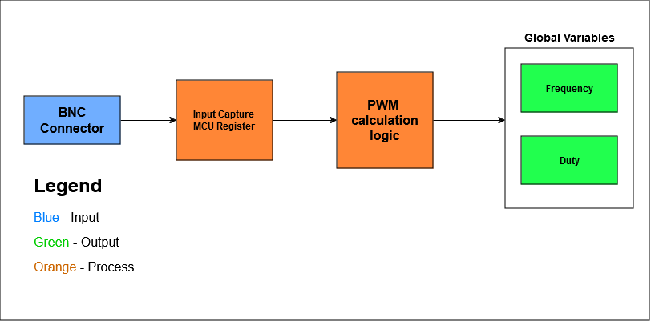

The PWM is calculated using 3 values sampled from an integrated timer on the MCU when the pin connected to the BNC jack encounters a rising or falling edge. After a 3rd value is sampled from the timer, a function with the PWM calculation logic is called. The external PWM’s frequency is calculated by subtracting the 3rd sampled value from the 1st and the duty ratio is calculated by subtracting the 2nd sampled value from the 1st then dividing over the inverse of the calculated frequency. It should be noted that the timer values are always sampled in the following order of conditions: rising edge, falling edge, and rising edge; this is done to ensure that the calculated duty ratio always denotes the time the output pin is logic-level high.

#### Encoder Control

There are two quadrature encoders that control the frequency and duty cycle respectively. The user is able to control the operating frequency and duty cycle either at 1kHz / 1% precision or 10kHz / 5% precision depending on the speed the encoders are rotated at. This design decision was made since a more complex incrementation/decrementation method was deemed unnecessary for this use case.

The turned encoder’s direction and speed turned are calculated in the MCU code. Because the encoders are polled at 1kHz, a turning speed of an encoder can be approximated and used to increment either frequency/duty ratio at 10kHz/5% or 1kHz/1% increments. Since the encoder code increments/decrements the global variables directly, a check is done to make sure incrementation/decrementation will not increase frequency or duty ratio passed the limits defined in the CONOPS document (1kHz – 300kHz and 5% - 95% for frequency and duty ratio respectively).

#### Push Button Control

The hardware supports—via 2-pin connectors—two push buttons used to control the device’s switching mode and toggle between internal/external PWM modes respectively. This was done over adding buttons directly to the hardware for testing purposes; The MCU code for the buttons denounces the input, so a custom signal simulating unintended input to the MCU GPIO was used to test this functionality.

#### Display

The display to be mounted on the front panel of the device is designated as NHD-3.12-25664UCY2, a 256x64 monochrome OLED display. This display was chosen due to its high contrast—suitable for the brightly lit laboratories this device will mostly be used in—and adequate resolution. The display is capable of displaying text and images. The font in Figure 4 was chosen due to its simplicity.

The display already came equipped with a driver chip, designated as SSD1322, thereby freeing time to write code for the display instead of designing driver circuitry. The driver/display component supports several types of interfaces, of which 8080 parallel interface was chosen; this interface was chosen over a more conventional 3 or 4 wire interface due to the abundance of I/O on the MCU, its relative simplicity, and the integrated Parallel Master Port (PMP) module in the MCU which is purpose built for communicating with parallel devices like this display.

Ultimately, the following architecture was used for the display code on the MCU (Figure 3).

**Figure 23:** Display Code Block Diagram

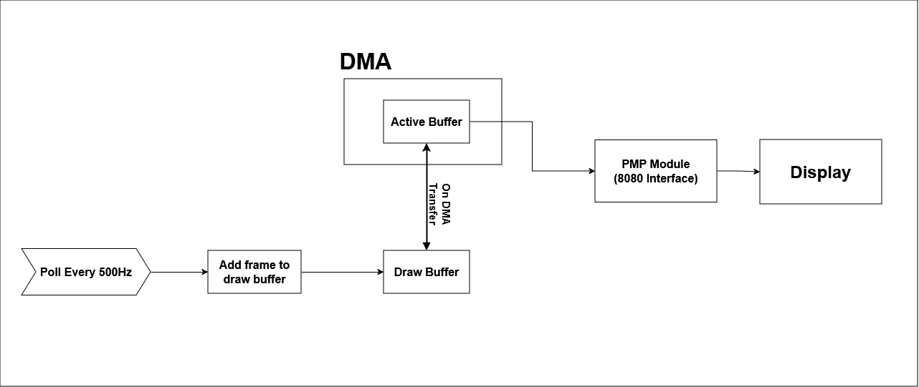

The display code uses a double buffer setup, with one buffer being written to the PMP module that writes to the display when its buffer is filled, and another being populated with the next frame information. The characters in the font *K2D Regular* were converted into a bitmap in order to load characters into the draw buffer.

#### Further Contributions

The microcontroller portion of the PCB was co-designed with group member Luke Bethancourt Figure 5. Additionally, the PCB assembly was undertaken. Figure 6 depicts the partially-assembled PCB board.

**Figure 24:** Altium view of MCU portion of PCB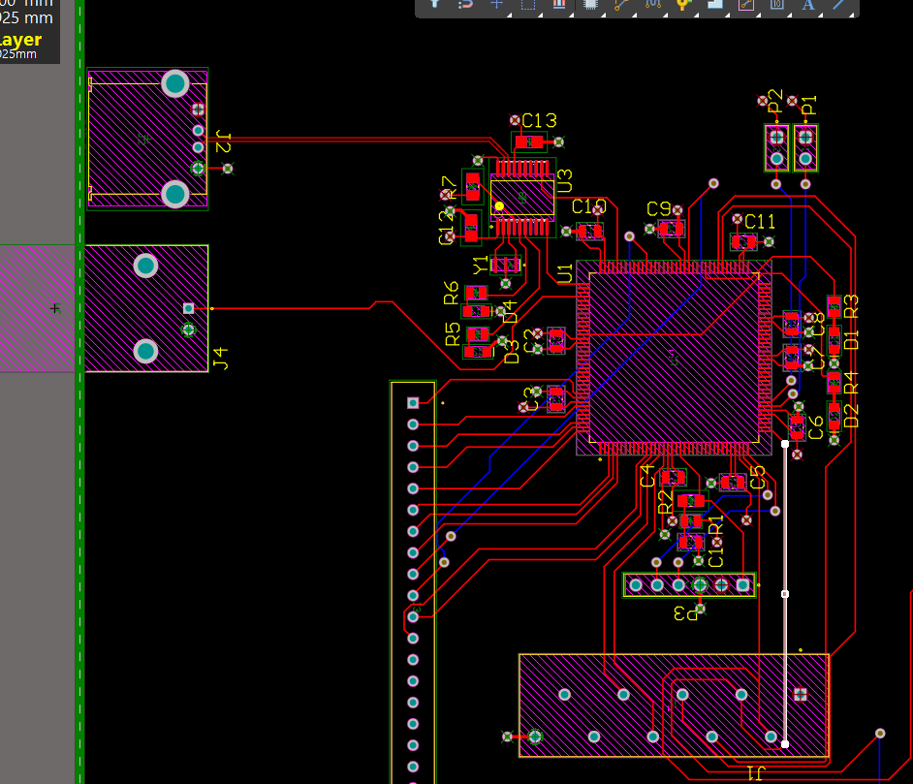

**Figure 25:** Photo of PCB in the process of being assembled

# 

### Subsystem Validation

#### External PWM Capture

The external PWM’s functionality was able to be validated via the PIC32 Curiosity Development Board (Dev Board). The test-pass condition of correctly calculating an external PWM’s duty and frequency were passed. The correct frequency and duty ratio were read using debug mode on the Dev Board, so the 2nd criteria of outputting the calculation result over UART was omitted.

#### Encoder Control

Both encoder’s were verified to meet the test-pass criteria via the Dev Board. The initial test methodology was adjusted so that the frequency and duty ratio adjustments could be verified via debug mode on the Dev Board

#### Push Button Control

The push button subsystem was verified to pass Test #1: toggling an LED via push-button on the Dev Board. Test #2 could not be verified as the final PCB implementation was unable to function. Possible points of failure could be soldering of MCU to board or defective a PIC32 component was used in assembly.

#### Display

The display was unable to be verified in its entirety, due to the MCU implementation of the board not working and the necessary MCU pins being occupied by a micro-connector on the Dev Board. Possible points of failure on the PCB could be soldering of MCU to board or defective a PIC32 component was used in assembly.

# Power Supply Subsystem

### Subsystem Introduction

The power supply provides power for all the electronic subsystems within the FET Control Box by taking in AC voltage and converting it to DC voltage. The input power comes from the wall socket power and includes circuit protection against higher voltage and current to prevent damage.

### Subsystem Details

The input port is a universal IEC style receptacle with a grounded AC line cord. An integrated fuse is built in to prevent current running higher than 250mA. A power switch controls the on/off state of the power supply, along with an LED indicating if power is on. The power supply can be powered from a range of 85-265 AC voltage. The current power supply design is a high power flyback controller to convert AC power to DC power of 12V 1A for each output.

The power supply has three outputs of 12VDC that are electrically isolated outputs to minimize noise and interference. Two outputs will be powering the power semiconductor subsystem that can run up to 200V and the other output is used to power control components (ex. optoisolators, microcontroller processor unit, LCD screen) 12VDC or converted to 5VDC using voltage regulator.

**Figure 26:** Schematic diagram of the power supply outputs

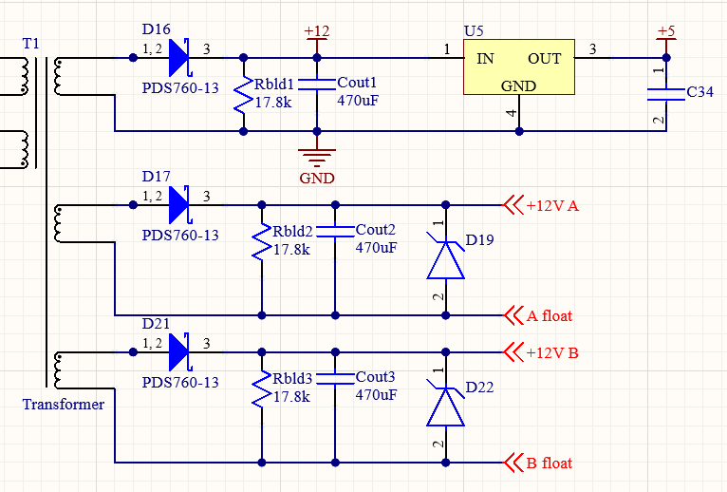

There is also a custom made transformer that provides the three isolated outputs, which will have two primaries as an input and the three secondary outputs.

**Figure 27:** Power supply section of the PCB (outlined).

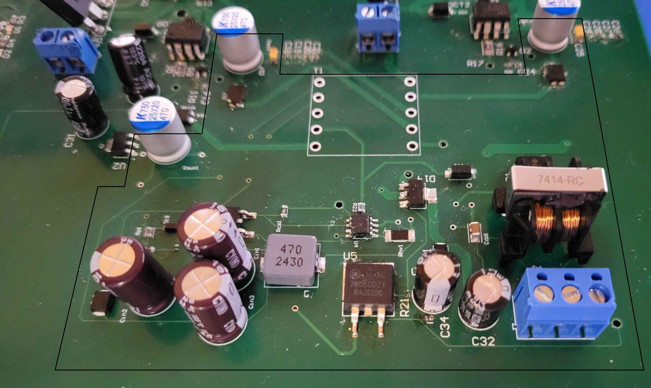

### System Validation

In order to prevent damage or injury, the power supply has been tested for shorts to prevent risk of arcing or breaking the board. Short testing used a range of low DC and AC voltages across components at all nodes to ensure that the voltages are not unintentionally shorted by design.

The subsystem has not been fully tested due to the custom transformer not being assembled on time. As the transformer is a critical component of the power supply, it can not power anything without it to transfer power.

Higher voltage testing has been put off for post final report testing due to an incomplete design and a high risk of injury.

### Subsystem Conclusion

A redesign of the power supply’s transformer to have it off-the-shelf or an outsourced custom transformer is to be preferred in this case for a professionally built transformer. Aside from that, the power supply had no other missing components needing to be assembled.

# 

# Power Semiconductor Subsystem

### Subsystem Introduction

The FETs are one of the primary components that the FET Control Box is built around. The FETs have a wide range of applications that can be used in lab experiments. One basic function is using it for a buck converter, where the DC-DC function is relatively simple except for the added switching from the gate drivers, which provides a fast switching signal to the FETs.

### Subsystem Details

**Figure 28:** Schematic diagram of the power semiconductors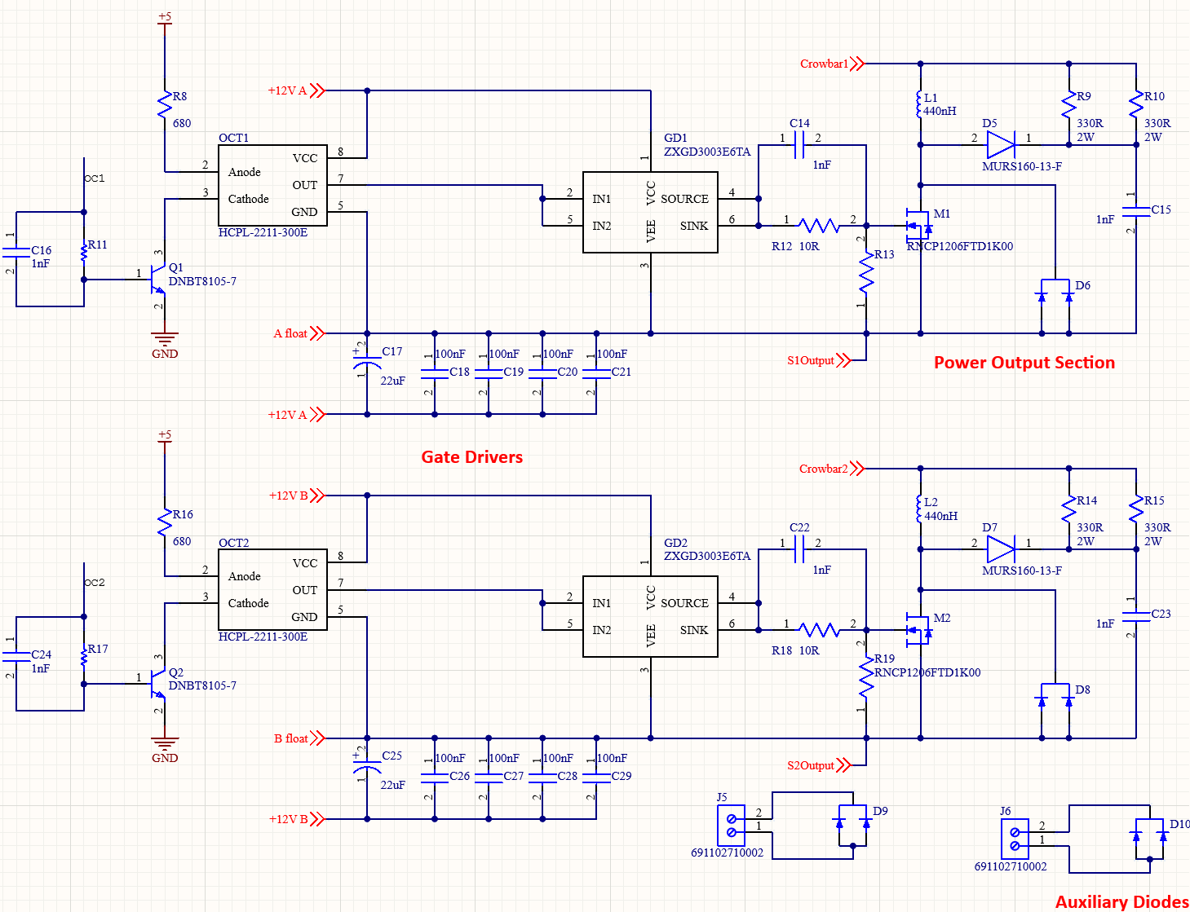

**Figure 29:** PCB of the FETs (M1 & M2) and auxiliary diodes (upper isolated connectors).

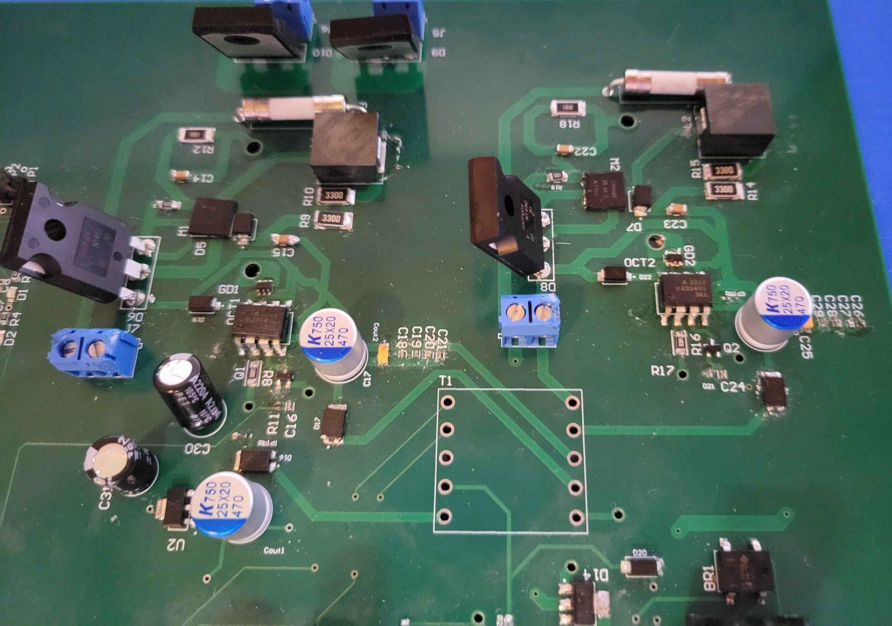

* + 1. ***MOSFETs and Diodes***

The power semiconductors include two identical pairs of independently isolated power diodes and MOSFETs. The gate driver is driven by the q(t) square wave signal from the PWM signal generator subsystem that goes through as a transistor then an optoisolator. A gate driver in each pair provides a switching signal to the FETs using the output signal from the optoisolator.

Two auxiliary diodes are isolated from everything else and are provided as outputs for use in external circuits.

* + 1. ***Circuit Protections***

Since there is no ground, power in the subsystem can reach hundreds of watts, which has a high likelihood of damaging components from even a brief voltage spike. To reduce such occurrences from happening, components are typically chosen for 400V as a minimum and 15A to withstand the 10A that the FETs designated max current can run at. As such, caution and careful considerations have to be taken when testing as well, as the ungrounded circuit can reach dangerous levels of power.

Since the max load of the subsystem is designed to be rated for 200V and 10A, minimum protection was put into the design to lessen the error margin between calculations and the results. On the old design, a lossy snubber mitigated voltage spikes from higher than rated voltages and a fast flow fuse was put at the output of D to prevent output current going over 10A (this fuse was not useful at all as the circuit would already be damaged by the time the fuse blows). In the new design, a crowbar circuit is added after the lossy snubber instead of the fuse to further protect against voltages going over 270V, as all the components are rated at a minimum of 300 volts. This way, the current and voltage are both regulated at the output of D as physical circuit protection. The crowbar circuit was added as a redundancy to a digital circuit protection system, which will be implemented in the future using voltage and current sensors, for extreme cases where the digital circuit protection fails.

### System Validation

* + 1. ***Test Circuit Set Up***

A simple buck converter test is used here to test the operation of the FETs using an external circuit. For this specific test, only one power semiconductor circuit is needed out of the two. A breadboard is not rated for the 20V 1A that the DC power supply provides, so a perforated board is used and components are soldered to keep them in place. The load resistor is 100 Ohms to withstand the power going through it. The twisted wires between the external circuit and the DC power supply is to lower the amount of inductance within the wires.

**Figure 30:** Test circuit for a buck converter 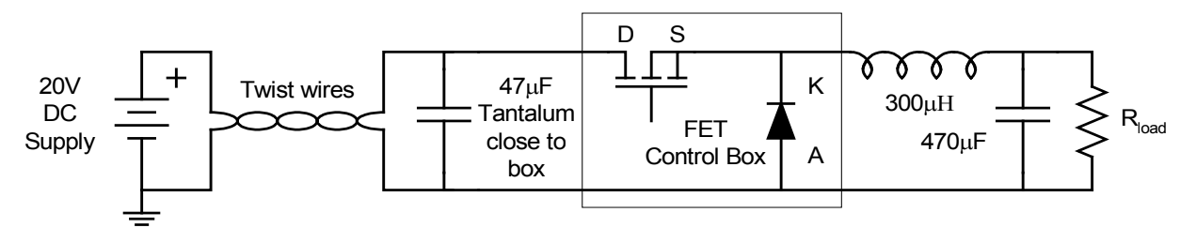

What is not pictured here is the q(t) signal generated by the PWM to the FETs (after going through the optoisolator and gate driver). However, since the PWM subsystem was not set up for this experiment, a wave signal generator was used as a substitute with a square wave setting, set at 5 volts peak-to-peak amplitude, 30kHz frequency, and a 50% duty ratio.

DC power supply is provided from the lab DC power supply generators, since the power supply of the PCB was not fully implemented during testing. Three different sources are provided to different points: 20VDC 1A to the external circuit, 12VDC 1A substituting as a power supply output, and 5VDC 1A to the optoisolator for powering the logic.

* + 1. ***Expected and Actual Results***

The expected voltages are about 45% to 50% of the 20V supplied at the load resistor. Expected voltages may actually be lower due to higher than the original planned load resistor (at 3.6 Ohms, 38W; unavailable due to no supply.), however, there should still be a DC voltage and an AC voltage (about 20 to 50 millivolts) as well.

The q(t) waveform should be measured at specific points to see its behavior and whether it maintains expected results at those points.

In the first test with the external circuit set up, a poor quality capacitor (47 microfarads, rated for 35V) burnt out with only 20 voltages from the DC supply. Measured voltage was approximately 14VDC. This test is not relevant due to an important part missing, as the q(t) signal generation was not provided and there was no switching signal from the gate drivers to the FETs. For the measured voltage load, 14V was measured until the capacitor burnt out.

In the second test, the burnt capacitor was replaced with a spare PCB capacitor with the same capacitance. A q(t) signal was finally added from a waveform generator device, using the square wave to emulate the PWM signal generation. Voltage at the load stayed relatively zero, so there were no notable results. After troubleshooting, the problem was that the FET was not outputting any voltage at all. The q(t) signal did not perform as expected as well, possibly due to an incorrect implementation of the waveform generation.

### Subsystem Conclusion

The subsystem was a disappointment, no meaningful results were found. The problem is found at the FET, which has multiple points of failure. It might even be a solder issue as well, since it was a poorly soldered component that was difficult to properly solder (minimal points of contact shown for soldering). Further troubleshooting is required to find the root of the problem and a redesign may very likely be needed.